**Services, Housing Stress and Emigration Survey**

**Survey Executive Summary**

A survey of the Lexington community was undertaken to assess key questions for the Residential Exemption: what portion of the community experiences high stress related to property taxes, how property taxes and high stress relate to migration decisions, and whether proposed tax exemptions would benefit members of the community with greatest need or least use of services. This appendix only considers survey data as a source of evidence, and by itself, does not constitute a comprehensive assessment of residential exemptions.

The survey was responded to by 1,475 individuals, or about 7% of the Lexington adult population. The survey results allow assessing whether relationships exist between demographic and tax data variables and two central variables of interest: housing stress and likelihood of leaving Lexington within ten years (migration). While both of these focal variables describe subjective experiences, the committee believes the broad outlines of the results provide insight into residential exemption policy.

Per the committee’s charter, two goals of a residential exemption would be to assist those with high housing stress (especially when property taxes contribute) or to impact decisions to leave Lexington. To discuss measurement of possible policies, we use the conceptual framework of precision and recall.[1] **Precision** is the percentage of those helped by a policy who are in the class of intended beneficiaries. **Recall** is the percentage of all intended beneficiaries assisted by a given policy.

Key Findings:

1. Renters much more often report high housing stress than homeowners.
2. High housing stress is reported at all ages, length of residence, incomes and home values.
3. Income is a better predictor of high housing stress than is home value.
4. Means tested targeting offers higher precision than the State’s Residential Exemption (SRE), but low recall.
5. Renters are more likely to migrate than homeowners.
6. Housing stress significantly drives migration for homeowners.
7. Home value and income are not significant predictors of migration for homeowners.
8. Middle aged populations have the highest forecast of migration.

Policy Implications:

1. If rental property owners pass on increased tax burdens from the State’s Residential Exemption (SRE) adoption to renters by increasing rents, it will impact a portion of the community experiencing very frequent high housing stress.
2. The SRE is a blunt (low precision) policy and will benefit many individuals with higher income or without high housing stress.
3. The SRE would negatively impact middle-aged members of the community who already have the highest likelihood of migration.
4. A Means-Tested Residential Exemption (MTRE) could offer higher precision, but would provide low recall as very few members of the community who experience high housing stress would benefit.
5. Survey respondents across all demographic variables are concerned about high property taxes in Lexington, and residential exemptions should be considered as one potential prong within a broader approach to addressing housing stress.

**1. Overview**

As part of our goal to gather information on what property tax challenges community members face, the Committee undertook to survey Lexington residents. We designed a survey which would collect information on services, housing stress, and migration plans, as well as demographic information allowing us to correlate responses. Furthermore, we gathered open response comments on two topics, although we ultimately decided not to correlate open responses with other questions because we had not disclosed that intent in advance and sought to protect individual privacy.

The central areas of concern for the Committee in addressing with this survey were:

Economic and psychological stress: What role does property taxes play in resident housing stress?

Migration: Is there any evidence that town tax policy impacts migration. For example, are individuals experiencing property tax induced psychological or financial stress more likely to leave Lexington?

Residential Exemption effectiveness: Can we estimate the effect of proposed exemption alternatives on either psychological stress or migration?

Justifiability: Can we estimate for proposed exemption alternatives whether recipients of an exemption are heavier or lesser uses or government programs?

Means-tested estimation: Can we estimate the number of qualified individuals for a means-tested residential exemption, and better characterize how they are differentiated from the population at large?

As a secondary benefit, we hoped these survey questions would shed insight into resident use of government services, housing stress, and other subjects which residents could address through open responses.

**2. Survey Process**

The committee developed questions and discussed in Committee sessions. The Committee was interested in ensuring that respondents would be willing and able to answer questions, and that the survey questions maintained relevance to purpose.

To measure representativeness of the population as a whole the committee sought widespread distribution verified by statistical testing. The proposed testing was to align demographic questions with census categories so one could measure whether the survey demographics aligned with known quantities about Lexington, such as age or income.

The Committee was concerned under what auspices the survey should be conducted. We wanted to avoid asking residents directly whether they would prefer lower taxes (in order to prevent biasing responses to “yes”), and also to maintain a reasonable level of obscurity about how responses could be used. Therefore, it was important that the survey not originate solely from the Committee.

We sought partnership with other town committees and departments interested in surveying Lexington, and found that while other surveys are in process, each one has its own timetable as well as varying levels of outside resources. Aligning with committees on different timetables was not feasible as it would delay our research. For the survey, we partnered with the Lexington Recreation Department which was also interested in how the use of recreation resources correlated with demographics. As one of our questions was about resource utilization for affected populations (possible fairness criteria), this partnership aligned well with our mission, provided additional value to a town department and offered an additional distribution channel, creating an overall “Services and Housing Stress” theme for the survey.

Draft questions were piloted with colleagues and friends, particularly outside Lexington. Piloting provided some feedback and raised some questions for the committee to address, such as:

What does it mean to receive fire or police services? Is getting directions from a police officer a service? How about being written a parking or speeding ticket? The committee left this ambiguous in the survey.

Did we need to ask marital status? What did this mean for non-traditional family organization? We decided to drop a question on marital status and replace with size of household.

What was the survey “getting at” in asking about race? Because the survey was themed around services and stress, race did not strike some pilot respondents as relevant, and while there could be insight into subcommunities, the committee determined it was not central to our line of inquiry and dropped the question.

Pilot respondents warned the committee that intrusive questions unrelated to the theme might cause survey abandonment. Therefore, each question was carefully weighed for the value it would provide versus potential abandonment effects. Because financial questions were critical to correlation, we needed to include those questions. However, we strategically placed these questions last so we would collect some information from respondents who might submit partially completed surveys.

Because the State’s Residential Exemption is based on assessed value and not economic means, the Committee had interest in how vacation homes and snowbirding factored into Lexington residency. Did some members of the community declare residency in Florida for tax reasons, and what action would they take if their Lexington property were to be charged materially higher taxes? But the theme of the survey and appropriate length prevented us from including any question which would provide insight into how residency and multiple-property ownership operated.

The Committee also discussed the respondent’s ability to answer questions. Would a less-financially aware respondent (perhaps the household member who does not manage finances) be able to answer questions accurately about market value, assessment, mortgage, property taxes, or insurance? The State’s Residential Exemption is related to assessed value, but except for the most financially aware tax payers, we expect many residents do not know their current year assessed value. Do residents know their total housing cost? Would some include cable or water and sewer, while others do not?

Our challenge in surveying these concepts in a clear manner for all residents, led to an innovation and some simplifications. One innovation was to introduce the concept of “housing stress” as an intended catch-all for the economic and psychological impact which monthly housing bills may have on a household. In keeping with our charge to support residents remaining in their homes, we reasoned inclusion of both objective factors such as migration as well as economic and psychological factors such as ease and stress, was important. So querying housing stress was intended to capture the psychological expression of the impact housing costs have on a household.

Surveying housing costs is a complex area, and the Committee accepted obvious limitations beyond a respondent’s ability to answer questions. The survey did not ask whether someone with a high housing payment would continue to have it into the future (Are they near the end of their mortgage?). Also, the causes of housing costs are unknown (Is debt required to live in the home, or to add a nice addition, pay for college costs, or a senior’s assisted care?). The survey asks about monthly housing payments, but does not encompass the origin, purpose, future trajectory, or total liability associated with these costs.

As the Committee was interested in property taxes specifically, we asked what proportion of housing costs are related to property taxes. Combined with market value of a home and monthly payments, these questions can give some insight into whether the respondent has material housing debt payments.

The Committee considered how to handle respondents who might not have satisfactory knowledge of core questions around housing payments and household housing stress. The committee felt that respondents should state that they are “responsible” for housing costs to be included in final data analysis about property taxation.

**Survey Structure**

We structured the survey to begin with questions about use of town resources, attempting to set the tone that this survey was not about property taxes per se. Section two, on affordability, started with questions of interest to the recreation department, such as access to financial aid. The first question central to our investigation was about housing stress, and this was followed by an open response question. The open response question thus reveals what respondents are thinking about when asked about housing stress--before the topic of property taxes was introduced (although being a town survey, taxes may come to mind easily).

The survey was constructed using Google Forms. We requested that responses only be submitted by current Lexington residents, but created no residency verification process. We wanted to maximize response rates, so did not request individuals identify themselves, and therefore could not prove that each person answered the survey only one time. The final results were downloaded from Google and processed via Python.

The survey contained the following sections and questions:

**Section 1: Town Services**

All questions start with this phrasing:

In the past 12 months, has any household member done the following?

These are the question numbers for responses:

Q1. Visited the Community Center

Q2. Used town swimming facilities

Q3. Used town recreational fields or courts

Q4. Used Pine Meadows golf course

Q5. Used a school or neighborhood playground

Q6. Used the Minuteman Bikeway

Q7. Used Lexpress bus

Q8. Visited Lexington conservation areas

Q9. Directly received fire or police services

Q10. Attended Lexington public schools

Q11. Participated in any town provided program or service for seniors

Q12. Used Cary library or attended a library event

Q13. Served town government in any capacity (employee, committee member, town meeting member, elected representative)

[Responses

All questions in section 1 allowed “Yes”, “No” and “N/A” as responses. We provided “N/A” as an option to allow respondents to explicitly skip questions, but we treated those responses the same as blank ones.]

**Section 2: Affordability**

Q1. Are you aware that the Recreation & Community Programs Department offers financial aid for programs and services?

Q2. Has a household member received this type of financial assistance to participate in a program or service?

Q3. If your primary residence is rental, please indicate your monthly rental cost:

Q4. If you own your primary residence, please indicate your total monthly housing payment (mortgage, insurance, property taxes):

Q5. Do you receive a property tax deferral or property tax credit due to limited income?

Q6. What level of stress does your household experience with payment of monthly housing costs?

Q7. Please elaborate or share any additional thoughts. (open response question)

Q8. Thinking about all the costs of living in your owned property or rental (rent/mortgage, home maintenance, condo fees, property taxes, insurance, utilities), what portion of these costs do you estimate is related to property taxes?

Q9. Are you responsible for the housing costs at your residence (i.e. owner or lessee)?

Q10. Are you considering relocating away from Lexington in the next 10 years?

[Responses:

Q3: $0-$1499, $1500-$2999, $3000-$4499, $4500+, N/A

Q4: <$2,000, $2,001-$4,000, $4,001-$6,000, $6,001-$8,000, $8,001-$10,000, $10,000+, N/A

Q6: None, Little, Some, Significant, Substantial, N/A

Q7: Open response

Q8: None, Little (1-25%), Some (26-50%), Significant (51%-75%), Substantial (76%-100%), N/A

Q10: Definitely Not, Unlikely, Undecided - Possible, Likely, Definitely, Have not considered, N/A

Others: Yes, No, N/A]

**Second 3: Demographics**

Q1. Age (respondent)

Q2. Size of household (number of people)

Q3. Disabilities within household (check all that apply)

Q4. Length of time living in town (respondent)

Q5. What type of property is your residence?

Q6. Approximate market property value of your Lexington residence (if owned):

Q7. Please indicate your approximate household income in the past 12 months

Q8. Please indicate how the survey was shared with you (any groups or lists or whether it was forwarded to you.) (open response question)

Q9. Please share any comments to the survey team about this survey. Thank you. (open response question)

[Responses:

To facilitate consistency between our survey with other population measurement tools, we chose demographic brackets used in the United States census via American Community Survey.[2] We made some adaptations to better reflect Lexington’s local population and to target demographics of interest to our focus on head of household decision-making. For example, we combined all age brackets below 30 years old. Similarly, we combined house value brackets below $500,000 because there are few in Lexington’s current housing market. We also split up the highest ACS bracket ($1,000,000+) into 5 novel brackets because of the abundance of houses above that threshold in Lexington. These were exceptions, however; most brackets remained consistent with ACS.

Q1: Under 30 years, 31-39 years, 40-49 years, 50-59 years, 60-69 years, 70-79 years, 80 years and over, N/A

Q2: 1, 2, 3, 4, 5+, N/A

Q3: Checkboxes so multiple section possible: with a hearing difficulty, with a vision difficulty, with a cognitive difficulty, with an ambulatory difficulty, with a self-care difficulty, with an independent living difficulty, none of the above, N/A

Q4: Moved in 2015 or later, moved in 2010-2014, moved in 2000-2009, moved in 1990-1999, moved in 1980-1989, moved in 1979 and earlier, N/A

Q5: Single family home, multi-family home, condominium, apartment, other, N/A

Q6: I don't live in a property owned by a family member, Less than $500,000, $500,000-$749,999, $750,000-$999,999, $1,000,000-$1,249,999, $1,250,000-$1,499,999, $1,500,000-$1,749,999, $1,750,000-$1,999,999, $2,000,000 and more, N/A

Q7: Less than $35,000, $35,000-$49,999, $50,000-$74,999, $75,000-$99,000, $100,000-$149,999, $150,000-$199,999, $200,000 and over, N/A

Q8 and Q9 were open response questions.]

**3. Survey Respondents**

Considering the fact that this survey had zero administrative and distribution costs, the committee conservatively hoped for 400 responses. Expecting a relatively small sample, the Committee did not anticipate nuanced results, and emphasized alignment with census categories for representativeness.

The survey ran over the period October 9, 2018 to November 16, 2018 and netted 1,475 responses. Given the frequent open response comments, one can reasonably interpret that respondents were eager to provide their opinions on housing stress and this was an important survey. Numerous respondents thanked the surveyors for providing an opportunity for them to comment about property taxes and services in Lexington.

During the short period the survey was open, the committee planned to track distribution channels to ensure broad reach among Lexington residents. We asked each respondent where they heard about the survey, giving us an idea of the primary distribution channels. However, as this was an open response question, the answers contained numerous variations with respect to each distribution path. Advice to future survey designers might be to provide a selection for consistency. This committee did not select that option because distribution channels were not all preplanned, and we anticipated residents would share the survey link among themselves as well.

A few noteworthy adaptations helped ensure widespread distribution:

1. The survey URL was changed to have a town government URL. (Some respondents were put off by unofficial looking URLs, which is not surprising given recent privacy invasions.)
2. Posting the survey on the town website provided assurance that it was official.
3. Department distributions (Recreation and Social Services) appeared to respondents as more credible.

One limitation was that the survey never identified which part of the town governance structure had initiated the survey nor the specific purpose for which it would be used. Some residents expressed discomfort or skipped the survey due to these issues.

The committee was delighted to have 1,475 responses in the end. The most frequent reported sources for survey receipt were:

|  |  |
| --- | --- |
| Survey source | Count |
| email: email, lex rec, forwarded, email from town, town email, email from lexington human services, email list, email from the town, via email, from lex rec, lexington recreation | 214 |
| facebook: facebook, lexington mavens, mavens | 57 |
| lexington list, lexington listserv, lexington email list, lex list | 38 |
| lexington at home | 9 |
| lexfun | 9 |

*We summed common responses and not the long tail of isolated responses, so these numbers are all undercounted slightly.*

The responses to this question informed us that no single source dominated.

The question asking whether a respondent has served in town government in any capacity was placed to monitor whether those serving in town government survey would be overrepresented in the responses, in which case it could be argued that political elites are surveying themselves rather than the wider community. The percentage of responses affirming a household member serving in town government was 17%, which reflects the high level of town participation in Lexington but perhaps some over-representation. However, with this modest figure, the Committee feels the survey does represent Lexington in total, rather than principally the views of those in Town Meeting or other committee positions.

We took response representativeness seriously, looking at both the fraction of the Lexington population represented and the distributional similarity to demographic census data. Lexington’s population is about 31,394 residents, and it’s 30+ population is 66% of this figure or 20,720. Of 1,475 responses to our survey, 1,469 were from the 30+ population, or about 7% of the target population. Looking at how representative of the population this 7% sample was, we can look at six demographic questions and compare with known data about the population.

**Age Representation (Q1)**

The following table compares the proportion of survey responses providing age, with age 30+ with the corresponding Census proportion for 30+ year old residents:

|  |  |  |
| --- | --- | --- |
| **Age Range** | **Survey %** | **2017 Census %** |
| Age 30-39* | 9.2% | 12% |
| Age 40-49 | 29.0% | 26% |
| Age 50-59 | 24.3% | 24% |
| Age 60-69 | 16.8% | 17% |
| Age 70-79 | 14.2% | 11% |
| Age 80+ | 6.5% | 11% |
| Total Respondents 30+ | 1,351 |  |

\**Age 31-39 survey*

*Census Source:* <https://censusreporter.org/profiles/16000US2535250-lexington-ma/>

The figures from the housing survey are comparable. The most noteworthy difference is that the 80+ year old population is under-sampled in our survey, relative to the Census proportion.

**Household Size Representation (Q2)**

The table below shows the proportion of survey respondents reporting household size:

|  |  |
| --- | --- |
| **Household Size** | **Proportion of Samples** |
| 1 | 8.3% |
| 2 | 27.4% |
| 3 | 17.4% |
| 4 | 34.4% |
| 5+ | 12.5% |
| Total Respondents Reporting Size | 1,363 |
| Average Survey Household Size | 3.2* |

*\*We assume 5+ has average of 5.2 to construct this average size.*

Census data indicates the average persons per household is 2.8 (<https://censusreporter.org/profiles/16000US2535250-lexington-ma/> (2017 ACS census). Our larger average survey household size may be due to under-sampling of age 80+ years.

**Residency Representation (Q4)**

We have not yet correlated the length of time in Lexington with Census responses

<https://censusreporter.org/profiles/16000US2535250-lexington-ma/> (2017 ACS census). The Census data requires further study.

**Home Value Representation (Q6)**

Respondents were asked for their home value. Some may have interpreted this as market value and others as assessed value. We believe market values may be 10-20% higher than assessed values.

We have not gauged representation formally here, although the frequency distribution of responses shows that all segments of home value have representation.

TBD. Use detailed assessment database to compare formally.

**Income Representation (Q7)**

The following table compares survey responses for income with the 2017 Census:

|  |  |  |
| --- | --- | --- |
| **Income Range** | **Survey Sample** | **2017 Census** |
| < $50,000 | 7.5% | 17% |
| $50,000-$99,999 | 16% | 13% |
| $100,000-$199,999 | 35% | 29% |
| $200,000+ | 41% | 40% |
| Survey Respondents reporting income | 1,154 |  |

*Source:* [*https://censusreporter.org/profiles/16000US2535250-lexington-ma/*](https://censusreporter.org/profiles/16000US2535250-lexington-ma/)

This table suggests the survey under-represents the portion of the community with incomes below $50,000.

**Rent versus Own**

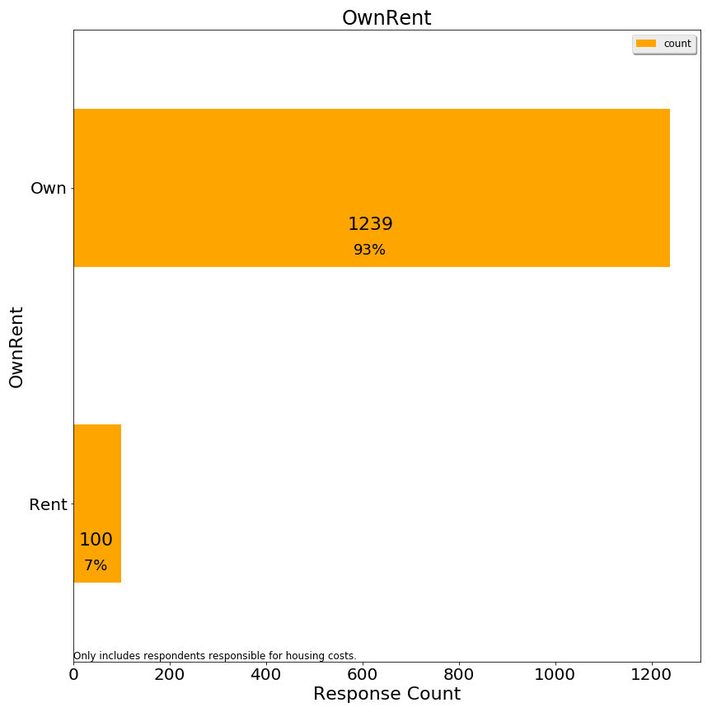

1,339 respondents responsible for housing costs provided data from which to infer whether they rent or own. For survey responses, if monthly rental cost was provided, the observation was recorded as “rent”. If the monthly rental cost was not provided, and the market value of the home was provided, the observation was recorded as “own”. If both fields were blank, then the respondent was not coded with either. The survey suggests 7% of respondents rent and 93% of respondents own.

ACS census data (<https://censusreporter.org/profiles/16000US2535250-lexington-ma/>) reports that 19% of Lexington housing units are renter occupied. However, this is not equivalent to the percentage of population living in rental versus owner units, nor the percentage of the adult population which is being surveyed. It does suggest that the survey under-represents renters to some extent.

**Error Corrections**

Twenty-nine respondents indicated housing costs in excess of $10,001/month and yet had homes valued at under $1.5 million. These cases were re-coded as “ResponseError” since it appeared that the respondent had interpreted the question as annually. For respondents with higher valued homes, this response seemed plausible and so those data were not re-coded.

**Grouping Responses**

For some analyses, grouping responses is helpful to see larger patterns. We grouped some responses to the following questions for some analyses:

Housing Stress: Grouped into Low Stress, Medium Stress, High Stress

Market Value: Lowest two categories combined into one

Income: Lowest categories combined

Age: Youngest two and oldest two categories combined, separately

Monthly Rent: Highest categories combined

Relocation: Grouped into Likely, Unlikely, and Neutral

**Principal Responses**

Because some respondents did not answer every question, we had a choice of imputing missing data or excluding observations which were missing any one key variable.

The committee elected to only include data in correlation analyses where the respondent was responsible for housing costs. With this constraint, correlation analyses include all observations where both relevant variables were provided. These analyses are split into owners and renters, since these two populations had largely divergent responses.

1,390 respondents answered affirmatively they were responsible for housing costs. These 1,390 observations are the maximum set of observations used to formulate the correlation charts. However, for statistical analyses, only 914 respondents provided an answer to all key variables, and therefore those analyses only used the observations with all variables. No imputation was performed.

**4. Results: Comparative Charts and Correlation Analysis**

**Renters and Owners**

The State’s Residential Exemption is an owner-occupied exemption, designed to provide benefits to owners. It has been adopted in cities and resort towns, in both cases shifting tax burden from (often voting) resident owners to non-resident owners. For vacation homes, non-resident owners absorb a tax increase, while for rentals an owner may attempt to pass through the rental increase to renters.

In analyzing the full impact of a State Residential Exemption would have for Lexington, the committee included both owners and renters. Stereotypically, renters have lower asset levels than owners, and one should examine how the State Residential Exemption would impact renters.

**4a. Focus on Housing Stress**

A key finding of the survey is that renters express high housing stress more consistently than owners, at all age and income levels:

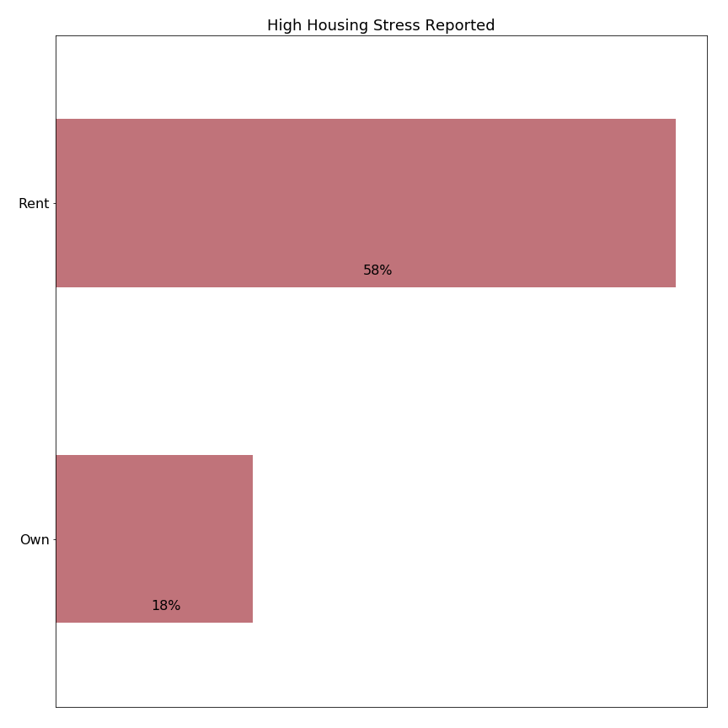

*%=percent within categories owning or renting indicating high stress*

|  |
| --- |
| *A note on interpreting single-color horizontal bar charts on stress and migration:*  For charts which only display “high housing stress” or “high migration likelihood”, we show a subset of all responses categorized by the y-axis label. The values in these charts reference the percent of respondents who meet the criteria displayed in the title (in the case above “high housing stress”) for each group. Thus, 58% on the renter bar means 58% of renters report high housing stress, and the other 42% are not shown in the bar chart.  Thus, the percentages shown do not add up to 100% vertically, but instead reference each category separately.  (Chart percentages are reported differently than frequency distribution bar charts where the percentages add to 100% vertically. A later note on stacked bar charts clarifies the color schema and grouping for stress and migration.) |

Housing stress may vary across subclasses of owners, but is less frequent than among renters in every case. For example, housing stress among owners is higher for those in lower value homes, but still well below the frequency of housing stress among renters:

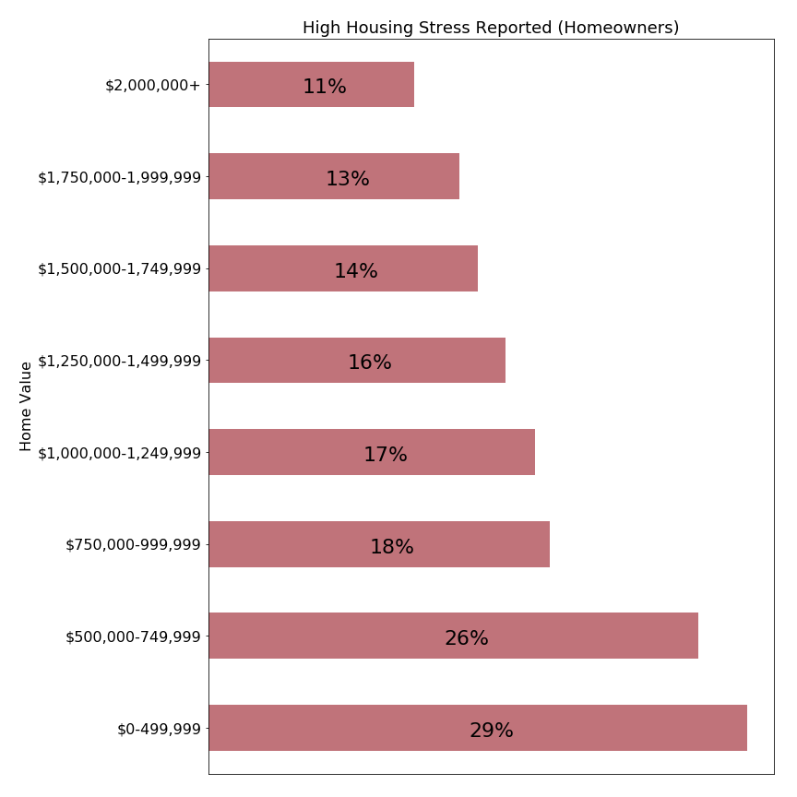

*%=percent within categories owning or renting indicating high stress*

One explanation is that renters may be stressed knowing that many are not in permanent situations. It must be incredibly stressful to be paying $3000/month in rent and trying to save for a down payment on a permanent property while housing prices escalate at high rates.

In the context of these results, policy makers considering adopting the State’s Residential Exemption should consider the social effects of potentially transferring a tax burden from owners to renters. Nationally, renters typically have lower total assets than owners, and the United States has a policy of subsidizing owners over renters through programs such as federal mortgage interest deductions.

**Housing Stress versus Home Value**

Within the class of owner-occupied homes, the State’s Residential Exemption is a progressive tax which shifts tax burden from those with homes below the breakeven point (just above $1,000,000 in Lexington) to those above that point. Our survey can help answer whether the transfer of taxes is shifting from a more burdened to less burdened population.

Again, reviewing the relationship between home value and housing stress, we see that housing stress is more often reported for those in lower valued properties:

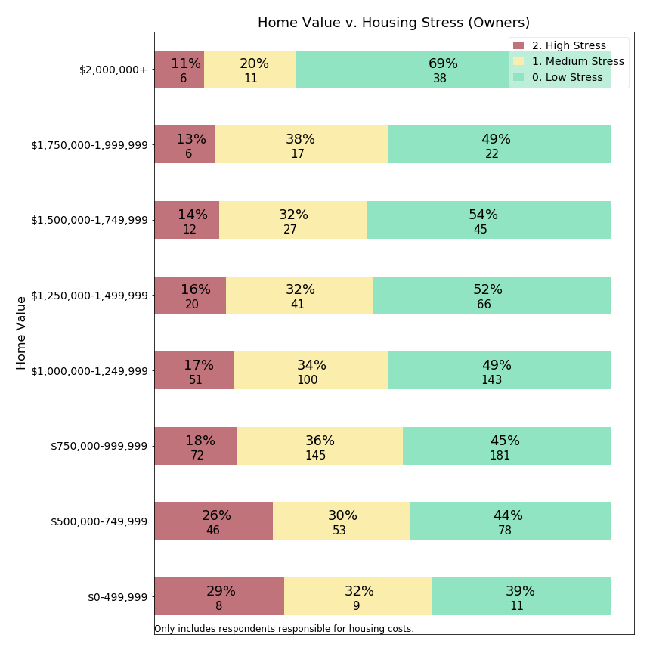

|  |
| --- |
| *A note on interpreting stacked horizontal bar charts on stress and migration:*  Colors: colors have been chosen to represent levels of the parameter being measured, in most cases “housing stress” or “forecast of intent to move”. Stress and intent to move were measured on a five or six point scale, but these are grouped into adjacent categories so an easily interpreted using a three color scheme.  Stacked bars: Each row corresponds to the entire number of respondents meeting the criteria labelled on the left (100%). A colored bar is shown with area proportionate to the respondents in that category (percent). Below the primary label showing the percent value is an integer value, representing the actual number of respondents. This actual number can be used to interpret the significance of the finding, as small counts (<20) have less reliability than higher number counts.  Interpreting percentages: these charts indicate the frequency with which respondents report a sentiment of the questioned intensity, which is different from the intensity. The language in the report attempts clarity by using a term like “frequency” to reference how often respondents indicated an issue. For example, in the chart above 29% report “high” levels of housing stress. But while high levels of housing stress are reported more frequently for lower market values, we cannot conclude that the housing stress is fundamentally higher than that at other levels, nor can we generalize to say that all members of this class experience such housing stress. |

How can this chart be used to understand proposed residential exemptions?

First, we note that Lexington has a high level of owner-occupancy, and therefore adopting the State’s Residential Exemption would largely transfer tax liability from those who own lower valued properties to those who own higher valued properties.

Survey responses indicate that 17-29% of homeowners with homes valued at under $1,250,000 report high housing stress. A residential exemption benefitting this all homeowners with houses valued at or below that point would have a relatively low precision, as three out of four beneficiaries did not report high housing stress. Such an exemption would be funded by homeowners with properties above $1,250,000, where 11-16% report high housing stress. While this is a smaller percentage than the lower value homes group reports, there are still respondents experiencing housing stress. A transfer of tax burden on to this population might exacerbate the high housing stress which already exists for some households.

Policy makers should also recognize that the impact of a tax shift could increase the extent of housing stress among high value property owners more than it provides relief to those with lower valued properties. A property owner with a $2,000,000 property would experience a property tax increase approximately double the tax reduction experienced by an owner with a $600,000 home. The survey does not measure how this shift would be experienced by either group.

**Housing Stress by Income: Owners**

Unlike the State’s Residential Exemption, means-tested residential exemptions include an income criterion to target residents who have demonstrated need. The chart below visualizes the relationship between income and housing stress of our survey respondents:

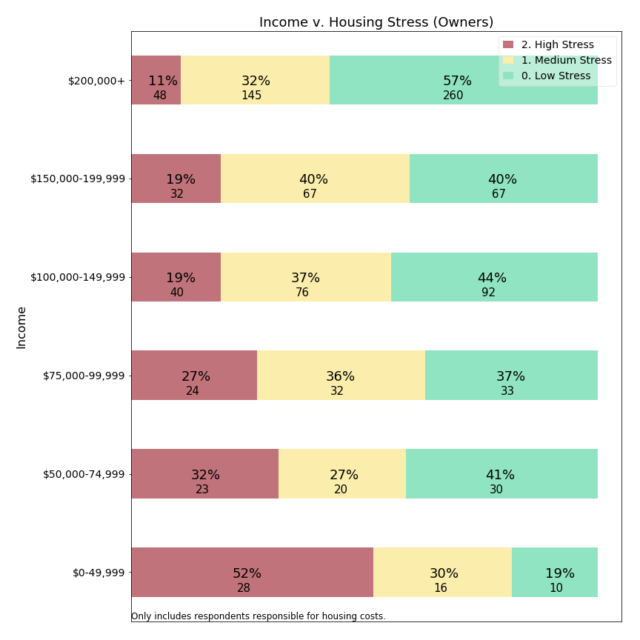

Homeowners with income below $50,000 report housing stress in 52% of responses, almost as frequently as responses from all renters. The second subset, those with incomes between $50,000-$74,999 report high housing stress in 32% of responses, a rate more frequent than in any market value category (see previous chart). Comparing this chart with the prior chart comparing home value versus housing stress suggests that including an income criterion for a residential exemption could better target residents with high housing stress than relying on home value alone.

The Massachusetts state circuit breaker provides assistance below an income cutoff of $58,000 for individual and $88,000 for married filers. Our charts suggest that Lexington residents below those income levels report housing stress more frequently than those above those thresholds. However, at those thresholds only about one in three residents report high housing stress.

High housing stress is reported among Lexington residents at all levels of income, so an income based cutoff cannot ensure property tax relief to all respondents stressed by monthly housing costs.

**Housing Stress by Income: Renters**

The state circuit breaker and some matching programs offer tax relief to renters. How well does income correspond to high housing stress for renters?

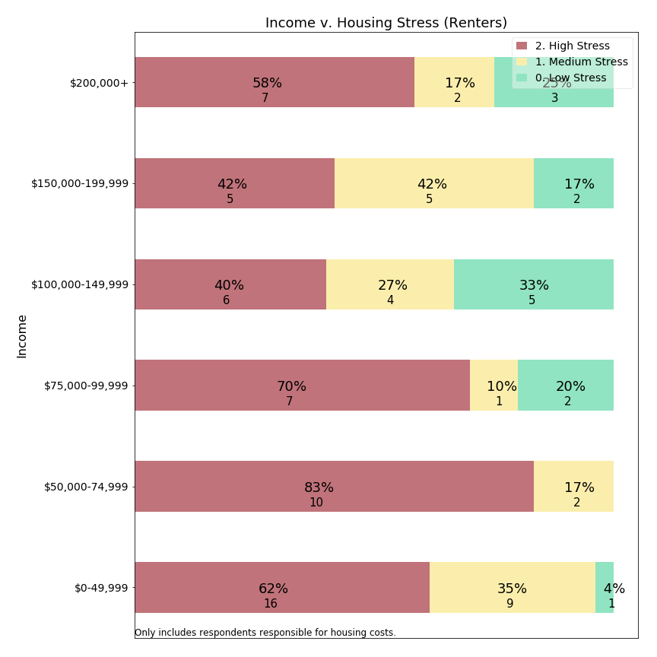

At first glance, it appears that high housing stress is prevalent across all income levels.

One observation is that, except for a single respondent, all responses for renters earning under $75,000/year indicate high or medium stress. This suggests housing stress is more consistently experienced among lower income residents than other residents.

A second point is that some low-income individuals living are living in rent-controlled properties and therefore may have lower housing stress due to controls in place. This chart does not pull out respondents with rent controls separately. Our survey did not ask for rent-controlled unit residency status among renters.

This chart suggests that creating meaningful means-tested programs for renters may be difficult, and reminds us that policies which shift tax burden from homeowners to renters may adversely affect a class of residents frequently reporting housing stress.

**Housing Stress and Monthly Rent: Renters**

Renters may have greater clarity about their overall housing costs, as capital costs, property taxes, water and sewer, and home maintenance are wrapped into a single rental tax presented by the property owner from whom they rent. While a renter may not know how property taxes factor into their monthly rent, they can report monthly rent and housing stress.

Moreover, the state income tax and circuit breaker calculations offer financial credits in relation to rent. For example, the Massachusetts state circuit breaker compares 25% of a resident’s rental cost to 10% of their income (whereas for owners it is 100% of property tax plus half of water and sewer). A means-tested exemption could use the same basis, which suggests the survey should address the relation between monthly rent and housing stress:

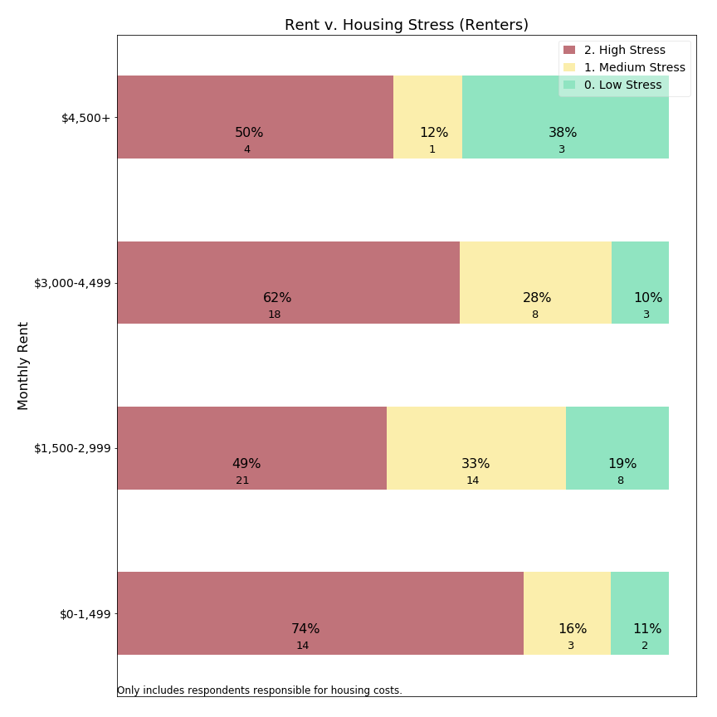

Our data suggest that housing stress levels are high, but fairly consistent across rental levels. Can Lexington support a residential exemption which would increase housing stress among renters?

An interesting point of focus is respondents reporting rents below $1,500/month. This group has pervasive high stress levels, but also is renting at below market rates (unless simply renting a bedroom--a rental arrangement not distinguished within our survey). This relationship suggests that households living in affordable housing are frequently reporting high housing stress. It also suggests that this one tier of renters may be immune from property tax burden shift from adoption of the State’s Residential Exemption; owners are not expected to be able to pass through property taxes to the small class of residents protected by regional rent controls.

**Housing Stress and Age: Owners**

Concern for Lexington’s senior population contributes to our examination of residential exemptions. Further, survey open response comments (below) explicitly mention retirement and fixed income as factors in relation to property taxes burden. The next chart visualizes the relationship between age and housing stress:

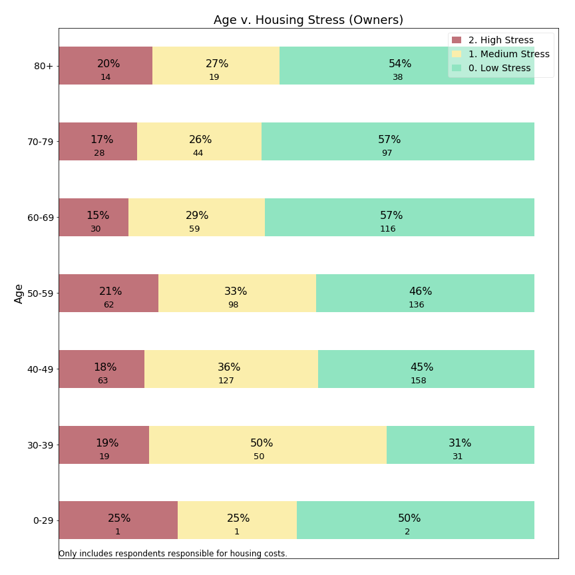

Considering both high and medium stress levels, it appears that the ages with most frequent housing stress are 30-59 year olds. Respondents between ages 60-79 reported less frequent housing stress, presumably because some households have moved past child care costs, mortgages and college bills. A small uptick may be occurring around 80+, but with limited statistical significance and with less frequent high housing stress than 50-59 year olds. The survey data suggests that housing stress may be experienced at all ages of the population, and does not provide statistical support for age-based criteria in means-tested residential exemptions.

**Housing Stress and Age: Renters**

The survey also allowed us to examine the relationship between housing stress and age for renters:

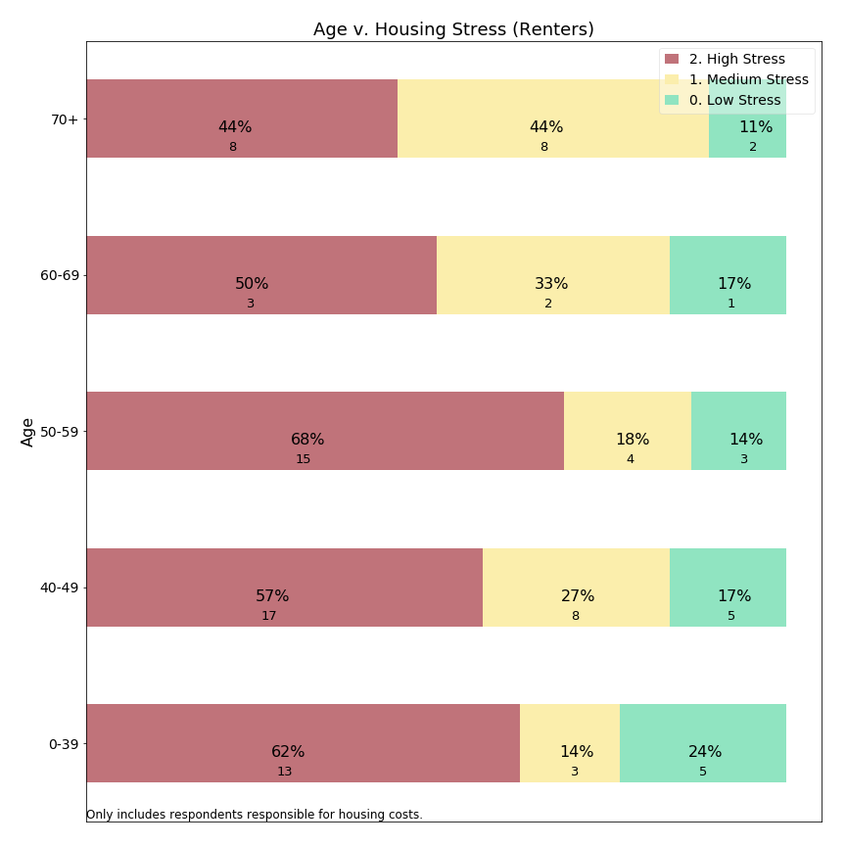

Renters in all age groups report high housing stress in half or more responses. For the oldest group, there could be a small decrease in frequency of high stress offset by responses of medium stress levels. As with owners, our survey data do not support a age criterion for a means-tested exemption.

(Note: For this chart, we combined the 70-79 and 80+ age classes into an age 70+ class due to the infrequent renter responses in this range.)

**Housing Stress and Time in Lexington: Owners**

Another criterion used for eligibility in means-tested residential exemptions is length of time in town. Therefore, we use the survey data to ask about the relationship between time in town and housing stress:

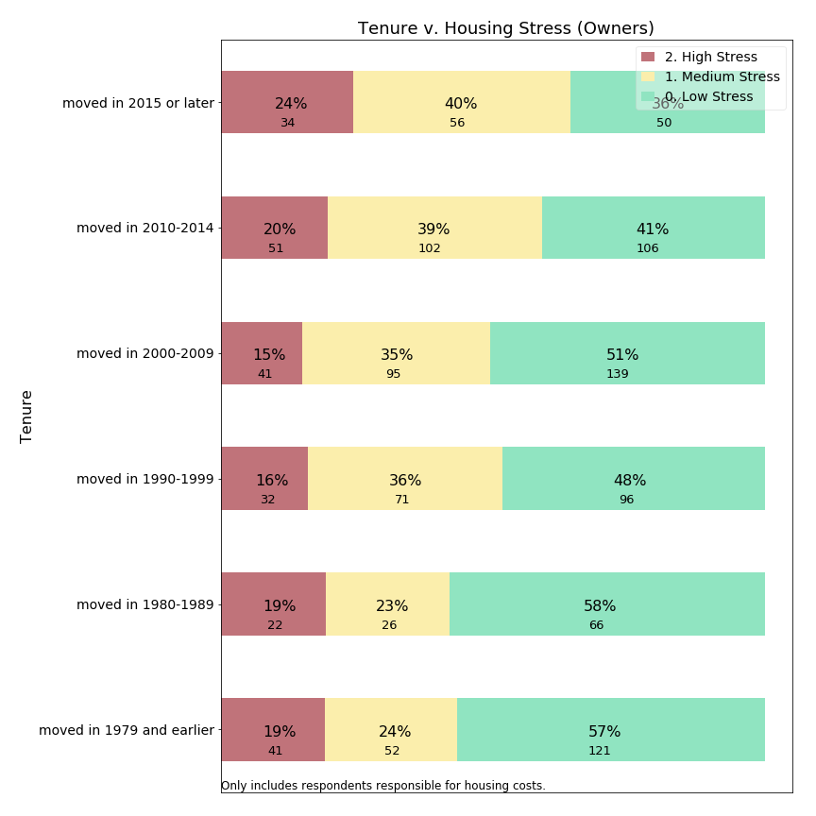

Survey data suggests that residents who have recently purchased homes in Lexington report housing stress most frequently. As these residents may have just assumed significant mortgages along with continuing housing inflation, they may have greater debt burden than more established residents.

While we do not observe that property taxes are causing this housing stress, we can state that housing stress data does not support a residency requirement for means-tested residential exemptions. However, it is likely these requirements exist for other purposes, such as to give confidence that new residents are not migrating into town to take advantage of tax relief intended for longer term residents overcome by compounded increases.

**Housing Stress and Time in Lexington: Renters**

Similarly, the survey allowed us to examine the relationship between tenure in Lexington and housing stress for renters:

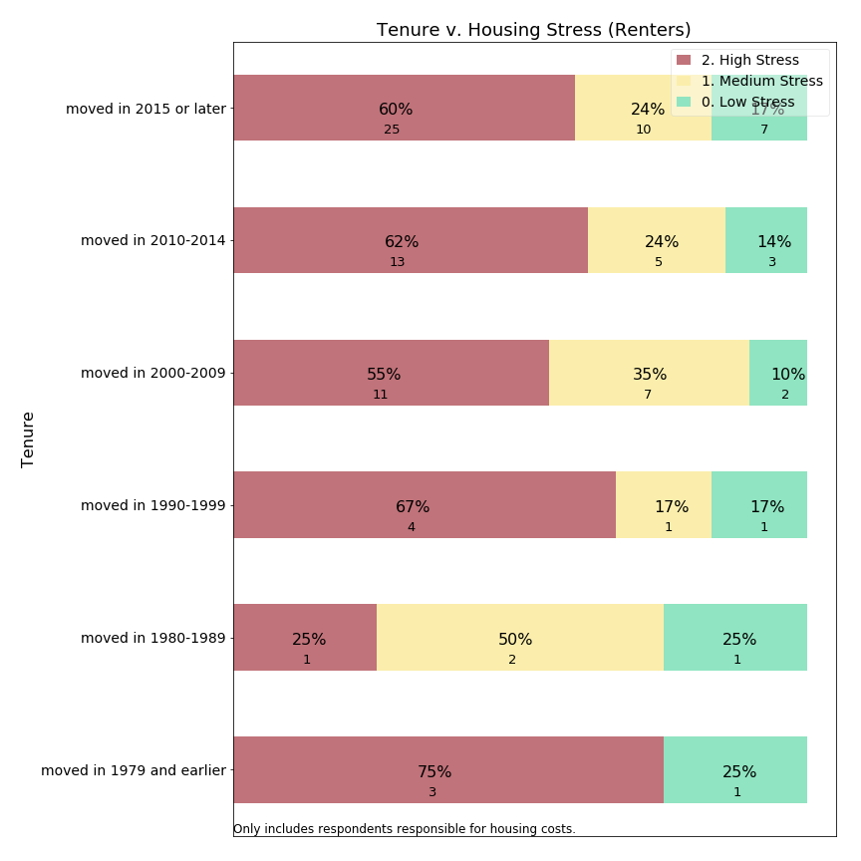

As with the prior metrics, renters express high housing stress at all lengths of tenure. The one exception appears to be renters who have lived in Lexington since the 1980s, but this group is too small to support a statistically significant departure from the larger group of renters.

**Housing Stress and Means Testing**

A typical means-tested exemption, following the Sudbury model, targets aid at residents who meet multiple criteria: senior age, low income, ten year residency, lower home value, and without “excessive” assets. Data from the survey can be used to ask whether residents meeting “Sudbury-like” criteria express high housing stress more frequently than do those who would be disqualified by one or more of the eligibility criteria. The survey responses only align with those criteria approximately because the survey thresholds were selected to match common census categories, which differ somewhat from thresholds listed in Sudbury’s “Senior Means Tested Exemption”. Furthermore, the survey request information about financial assets, nor does it ask whether the homeowner’s primary residence is in Lexington. The following table describes how Sudbury’s policy thresholds compare to the approximations we have used with regard to the survey data:

|  |  |
| --- | --- |
| **Sudbury Criteria** | **Survey Approximation** |
| Age >= 65 | Age >= 60 |
| Circuit breaker income, i.e.:  $86,000 joint,  $72,000 head of household,  $57,000 single | Income <= $75,000 |
| 10 year residency | Tenure since 2005 (13 years) |
| Assessed home value < $799,600 | Assessed home value < $750,000 |
| No “excessive assets” | [None] |
| Primary residence Sudbury | [None] |

*Source:* [*https://sudbury.ma.us/assessors/2018/05/31/fy-2019-senior-means-tested-exemption-applications/*](https://sudbury.ma.us/assessors/2018/05/31/fy-2019-senior-means-tested-exemption-applications/)

Concord’s experience with a means-tested exemption is that only about a quarter of those eligible for the state circuit breaker received a local exemption. The Concord assessor suggests that the $250,000 asset level test in Concord may have excluded many of the 75% who did not qualify. Therefore, we believe if Lexington adopted a similar asset test, that the survey approximation is casting a wider net, by not including an asset threshold, than would occur in practice.

By approximating “Sudbury-like” qualifications from our survey responses, we can compare those who meet all four criteria above (code=1) to those who did not (code=0) with respect to housing stress:

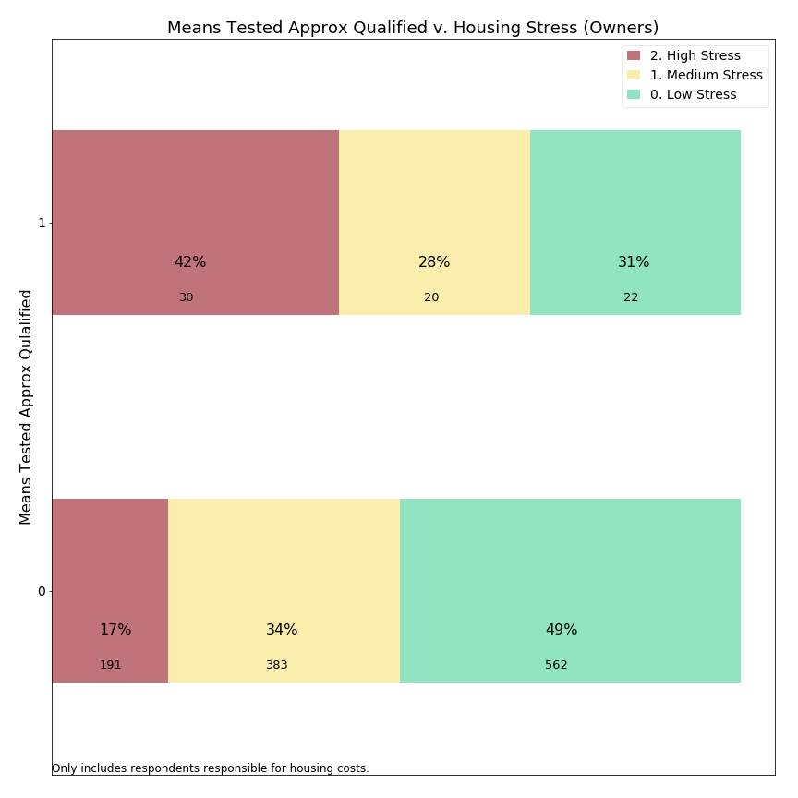

Among owners, those who met the survey means-tested approximation reported high housing stress 42% of the time, as compared with 17% of those who did not meet all the criteria.

The absolute response counts, however, lead us to a point we will develop further below: a means-tested residential exemption may have higher precision (42% of those targeted have high housing stress) than the prior series of charts (e.g. owners’ stress with regard to income, age, home value), while it would have a lower recall (30 respondents reporting high housing stress met the means-tested criteria compared to a far larger 191 respondents who did not meet all the criteria). If we had been able to include an asset test as well, one would expect precision to improve further, while recall would decline.

**Precision versus Recall, a Conceptual Framework**

As illustrated in the example above, shaping policy parameters forces us to acknowledge and evaluate trade-offs between reaching all community members who need assistance and not providing assistance beyond those with need. The concepts of precision and recall help us examine that trade-off. **Precision** is the percentage of those helped by a policy who are in the class of intended beneficiaries. **Recall** is the percentage of all intended beneficiaries assisted by a given policy.

The stacked bar charts presented above illustrates this inherent trade-off between precision and recall in the context of high housing stress among survey respondents who either would or would not qualify for a “Sudbury-like” means tested exemption. We make this evaluation by considering how each variable relates to housing stress and which portion of the population would meet the criteria. We imagine how the stacked bars might shift one way or another, shifting precision and recall, due to adjustments to the inclusion criteria (e.g. adding an asset test, changing the age threshold).

A more technical, but straightforward method to compare variables is to plot either receiver-operating characteristic (ROC) or precision-recall curves for each variable. Before doing this, we need to make explicit an assumption this Committee has made about the target population and our “housing stress” proxy variable.

Assumption: high housing stress is the portion of the population we are trying to target with our residential exemption policy choice. In the charts above, we assume a purpose of adopting a residential exemption would be to alleviate housing stress. We do not distinguish among sources of housing stress (mortgage, maintenance, property taxes) but try to understand whether those experiencing high housing stress could be assisted with tax relief.

In an ideal scenario, each resident would report accurately and honestly whether they experience housing stress, and only those actually experiencing housing stress would receive assistance. But because stress is a subjective concept, typical public policies would use a more objective proxy and offer assistance in relation to this proxy variable. Thus, we think about whether a respondent reported housing stress as “ground truth” and the proxy variable in question as a “classifier” and we evaluate which classifiers provide the best guide to ground truth.

**Precision** = percent of beneficiaries who have high housing stress

If 18% of home owners report high housing stress, Lexington could achieve a precision of 18% simply by offering financial assistance to any random subset of homeowners. The objective of a residential exemption should be to offer tax relief in a more targeted manner, significantly improving on an 18% random sample.

**Recall** = percent of those with high housing stress who are beneficiaries

If Lexington were able to offer tax relief to all residents, then 100% of those with high housing stress would be addressed. But if a random 10% of residents were selected for tax relief, then only 10% of high stress residents would receive aid, a recall of 10%. The objective of a residential exemption should be to offer sufficient recall that residents believe the program is meaningful and worthwhile in comparison to its implementation cost.

Using a fishing metaphor: Precision is how well your fishing net caught the kind of fish you wanted, versus other fish you caught inadvertently. Recall is how well your net caught the fish you wanted, versus the fish you wanted who were left behind in the ocean.

**Precision v. Recall Curves**

Each of the variables evaluated (home value, income, age, tenure) offer a distinctive trade-off between precision and recall. Considered separately a policy maker could select a cut-off for each variable and use that cut-off to determine an optimal trade-off between precision and recall. Comparing these curves is useful in helping policy makers determine which criteria provide the most targeted means to address housing stress in the community.

*Note on Precision-Recall Curves*

Each chart shows trade offs between precision and recall for the variable listed in the title of the chart.

Annotated points correspond to survey thresholds which could be used for policy cut-offs. Each potential cut-off has a separate balance of precision and recall.

Ideal public policy would be represented by a curve offering high precision and recall simultaneously.

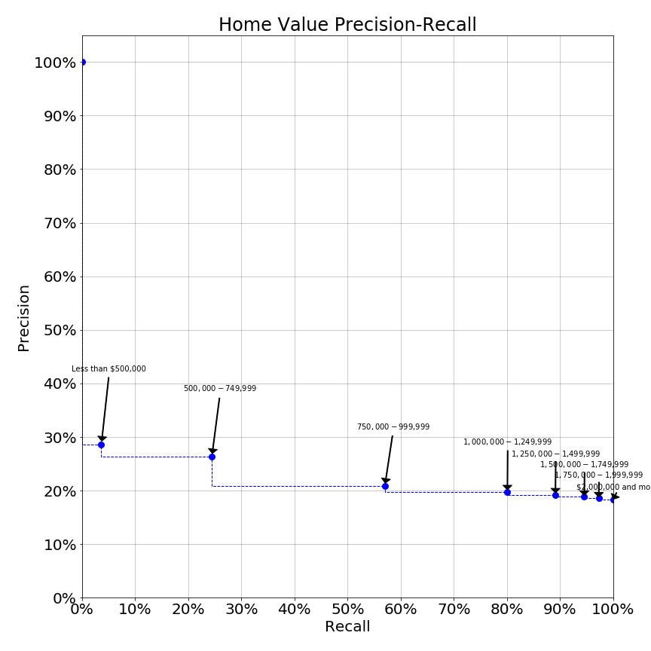

The home value precision-recall curve shows that an exemption policy targeting those with home values below $500,000 would have a precision of 29% (see corresponding stacked bar chart above) but the recall (% of high housing stress respondents reached) would be under 5%. Increasing the home value inclusion threshold to $750,000 greatly increases the reach (recall) of the program while only slightly diminishing targeting precision. Further increases in the threshold beyond $750,000 degrade precision such that the program would not be much better than random sampling of the population. Thus this curve would suggest that the SRE (which may benefit those up to ~$1,200,000) is correctly labelled a blunt instrument, but in fact appears to be only slightly better than random.

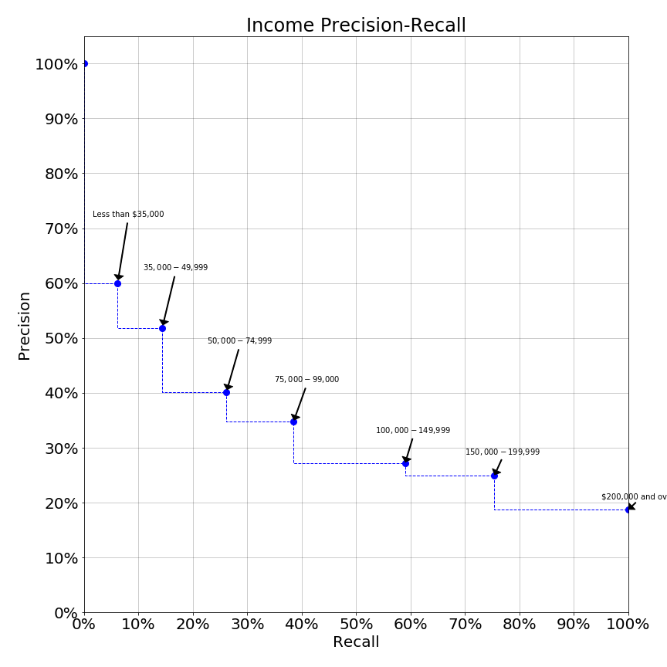

In contrast, the income precision-recall curve is dramatically sloped. Here, we see a curve which offers significantly higher levels of precision at a variety of thresholds. At income levels up to $50,000 an income exemption would have precision over 50%, such that over half the beneficiaries have high housing stress. Moreover, at this level about 15% of the population in need would be reached. Raising the income inclusion threshold to $75,000 reduces precision to 40% while expanding recall to one-quarter of those in need. While both precision and recall at either $50,000 or $75,000 income levels might not be as high as one might desire, use of precision-recall curves quantifiably demonstrates the superiority of income as an inclusion criterion over house value.

Other variables we examined produce precision-recall curves which indicate they would make poor inclusion criteria:

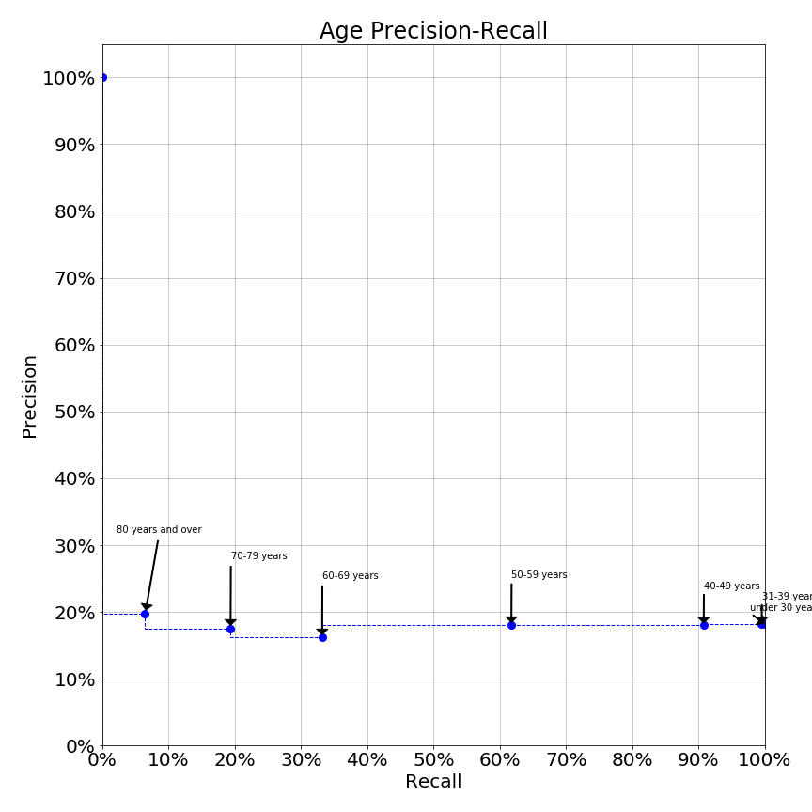

The age precision-recall curve suggests that some age thresholds may in fact perform worse than random selection (18% precision).

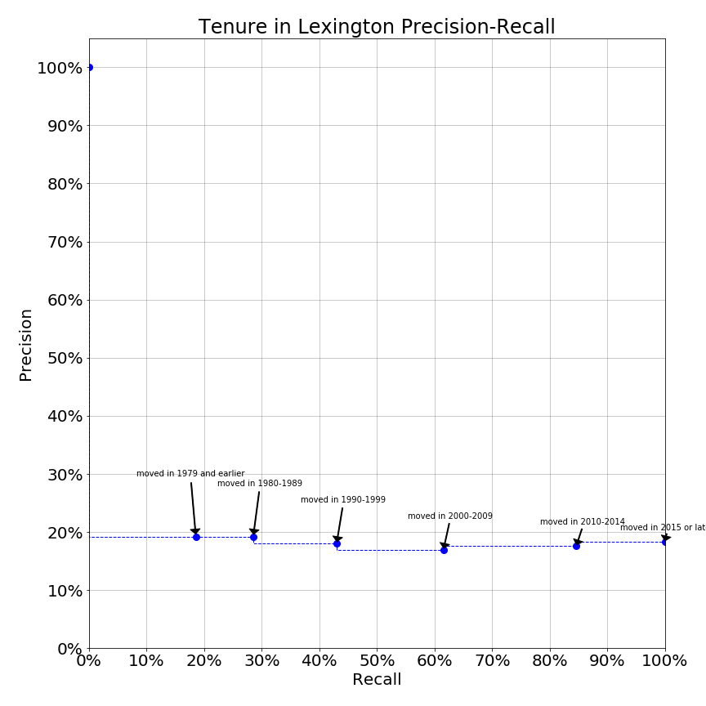

The tenure in Lexington precision-recall curve also suggests that length of time in Lexington provides no value in classifying residents’ high housing stress.

**Housing Stress and Monthly Housing Costs: Owners**

Lexington homes range in value from condominiums as low as approximately $500,000 to single family homes priced as high as $3,000,000. Individual assets vary, as some owners purchase homes outright while others have substantial mortgages. The survey data can be used to visualize the relationship between monthly housing cost and housing stress:

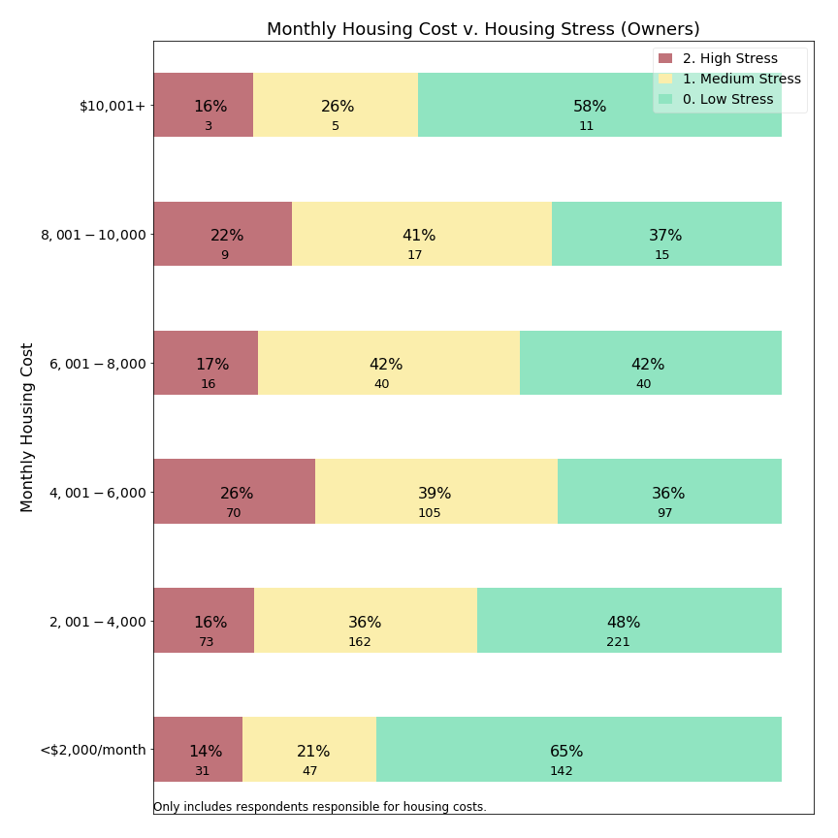

It appears that housing stress is similar across a wide range of monthly costs from $2,000 to $10,000 per month. Among the handful of residents paying more than $10,000 per month, housing stress may occur less frequently. A caveat is that some individuals in the $10,000+/month group were excluded from our this examination due to what appeared to be response errors explained earlier in this appendix (Error Corrections), and these individuals registered high stress more frequently. Among those paying less than $2,000/month in total housing costs, suggesting no mortgage and modest property taxes, residents most frequently report low housing stress.

**Housing Stress and Property Tax Percentage: Owners**

One way to look at whether property taxes relate to housing stress is visualizing the relationship between property tax share of housing costs and housing stress:

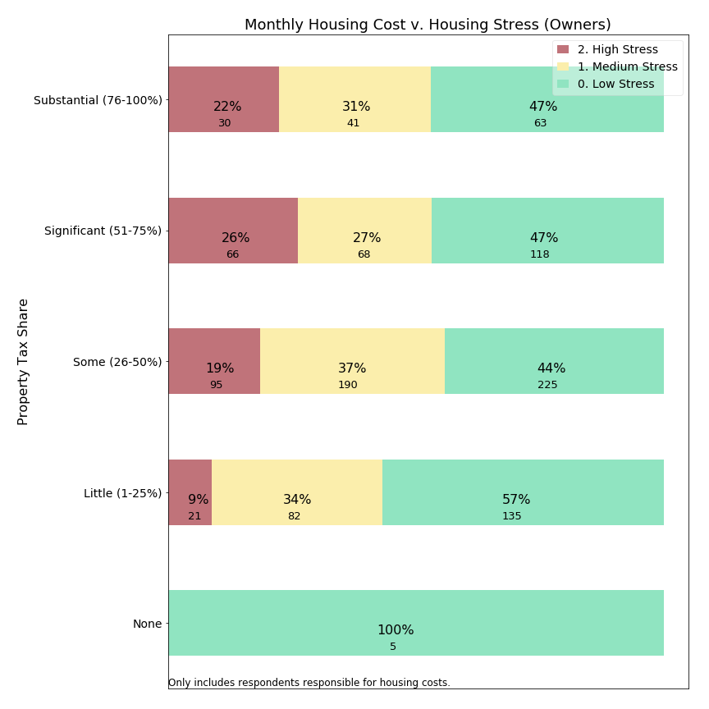

Among respondents reporting property taxes in excess of one-quarter of their housing costs, similar high stress levels exist to the general owning population. However, for those for whom property taxes are less than one-quarter of the monthly housing bill, high housing stress is reported only 9% of the time, or about one-half the rate for owners in general. This suggests that homeowners might be more comfortable when property taxes are only a small portion rather than the dominant portion of their housing costs.

**4b. Focus on Migration**

The Committee’s charge to support residents remaining in their home not only covers stress, but also whether residents appear “forced out” of Lexington. The survey asked whether the respondent is considering relocating from Lexington in the next 10 years. Arguably this is a subjective forecast, and actual migration occurs due to changes in life circumstances (such as employment relocation, marriage, grandchildren, divorce, limited mobility or injury, and death of a partner) at least as much as due to property tax burden. These questions measure whether the respondent gives serious thought to leaving Lexington, rather than whether they actually will move away. Moreover, a decision to migrate by itself might not indicate the respondent feels “forced out”. The sections below examine whether respondents forecast departure in the next ten years. The term “migration” is used for this forecast in the charts below, understanding this is a subjective prediction.

**Migration versus Owning and Renting**

As we have seen, the largest divide in housing stress is between owning and renting. Given the transaction costs of home ownership, it should not surprise us to see a divide in migration as well:

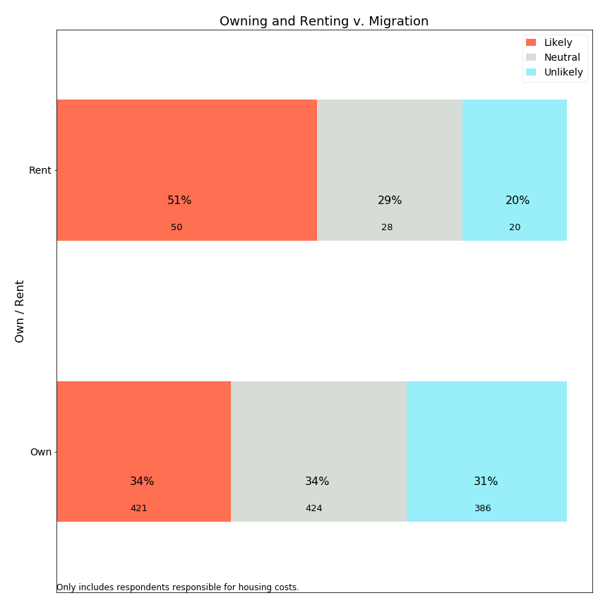

Perhaps the most surprising aspect of this chart is about owners, one-third of whom indicate intent to depart Lexington in the next ten years. Given actual migration patterns, which include moves due to unanticipated circumstances, this figure might seem higher than expected. What is driving half of Lexington’s renters and one-third of it’s owners to forecast migration? Is it related to property tax policy?

**Migration versus Housing Stress**

If property tax burden can affect migration, then we should expect to detect a relationship between monthly housing stress and migration intent. Some individuals with high monthly housing stress might seek to leave Lexington to reduce housing stress.

Alternatively, it is possible that even residents with lower levels of housing stress might forecast departures of Lexington to earn a better return on their housing assets. A $10,000 property tax differential between Lexington and Cambridge, for a similar priced home, could simply tip the scale.

Below is the relationship between housing stress and migration in survey responses:

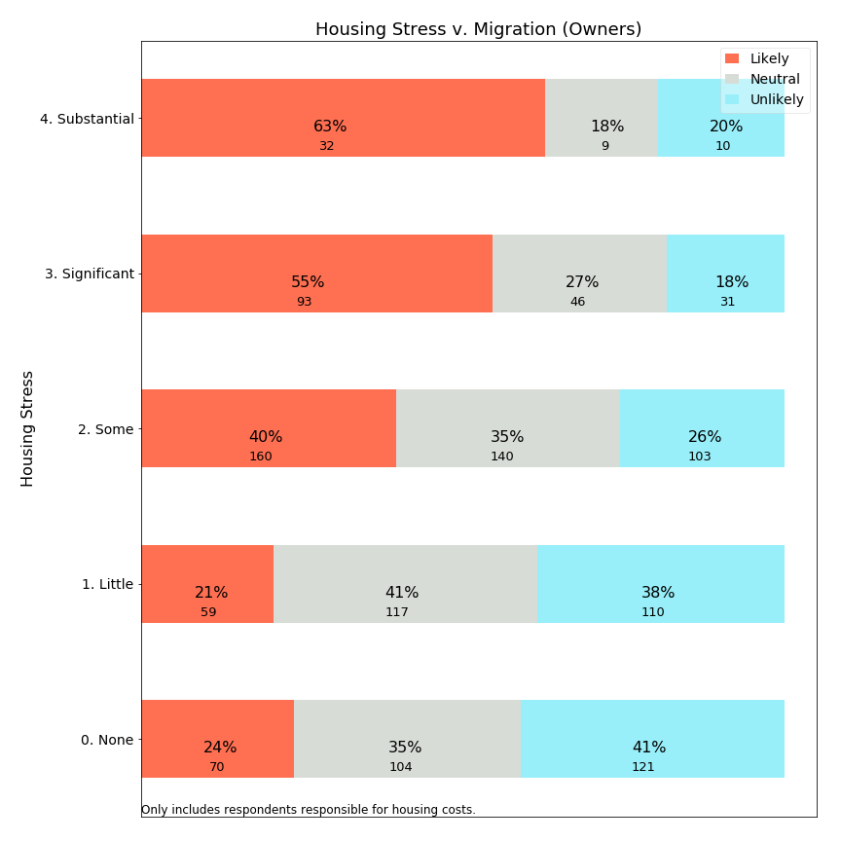

For owners, the survey data shows a strong relationship between monthly housing stress and whether respondents are considering migration from Lexington. For those experiencing significant or substantial levels of housing stress, over half are likely to depart Lexington. This compares with less than a quarter of those with little or no housing stress. (We assume causal direction from housing stress to migration.)

Is there a similar relationship between housing stress and migration for renters?

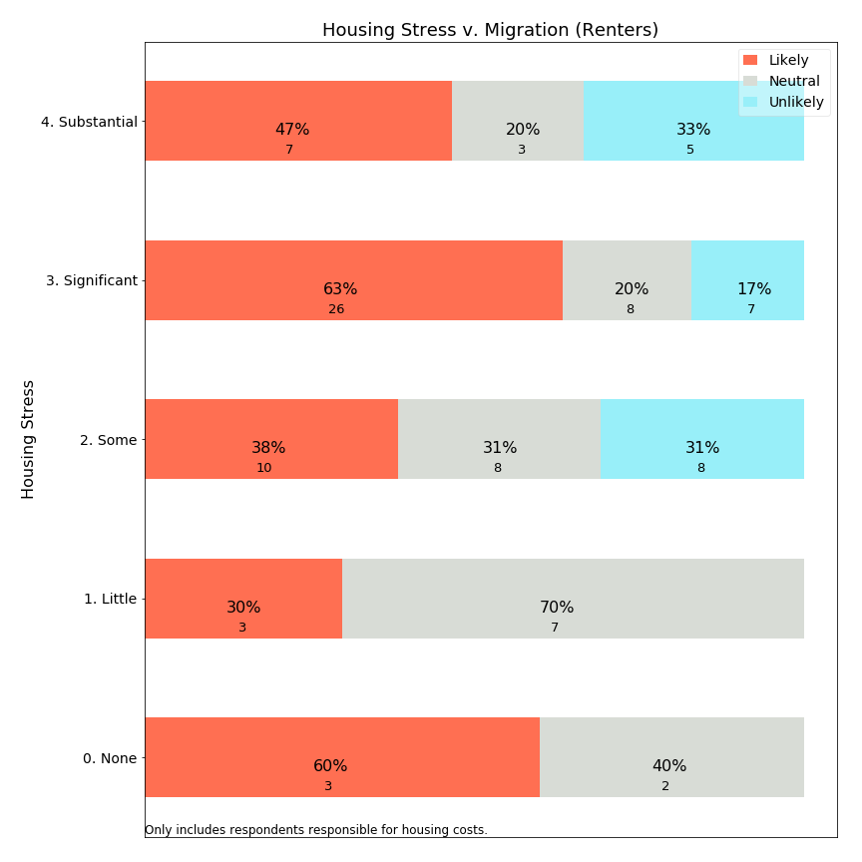

Discerning a pattern for renters is hindered by the small number of respondents for most level housing stress. Renters reporting significant housing stress are a sizeable group, however, and almost two thirds of them are likely to move away. Unlike home owners, renters may have lower transaction costs in adjusting housing and are able to migrate in response to service and cost considerations. It could be that higher migration is typically expected for renters, and rents respond more quickly to compensate renters for Lexington’s relative value in the rental market.

**Migration versus Home Values: Owners**

The SRE provides relief to owners of lower value homes. Is this group of residents more likely to migrate?

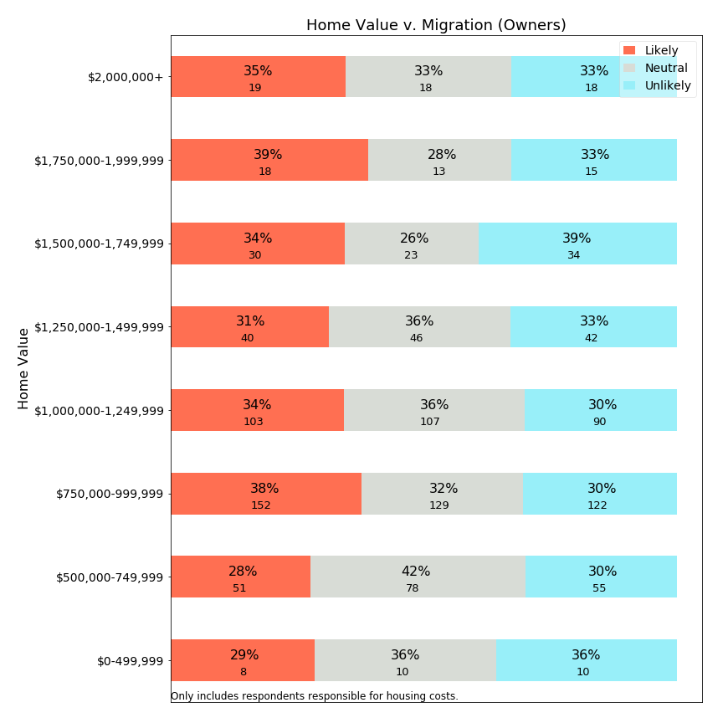

The survey data suggests that those living in lower valued homes forecast migration at slightly *lower* rates than those with medium or high value homes. If forecast migration rates are lower for those in low value homes, then it is more difficult to use this data to argue that a SRE protects these residents from being forced out of Lexington.

**Migration versus Income (owners)**

On the other hand, a means-tested exemption would use income as a criteria. Are lower income owners more likely to migrate out of Lexington?

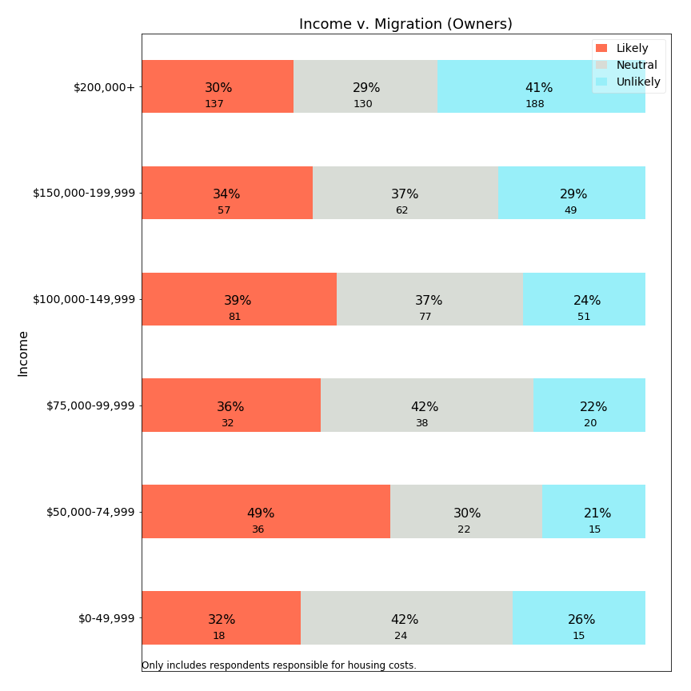

The survey data suggests that migration forecast is highest in the $50,000-$74,999 range and slowly declines with increasing income. While not a strong relationship, a means-tested exemption reaching up to $75,000 would benefit those in this subgroup. We cannot predict whether that benefit would change their migration choices.

An interesting exception to the general trend presented in this chart is respondents with income under $50,000. This group forecasts a lower likelihood of departing. Is it possible that some of these residents are in affordable housing and unable to realize similar value elsewhere? Alternatively, do their financial circumstances (including transaction costs associated with moving) make it difficult to leave, so that rather than being “forced out” they are “locked in”, but involuntarily?

**Migration versus Income (renters)**

Means-tested exemptions can provide tax relief to renters based on income. What does the survey data show about income versus migration forecast for renters?

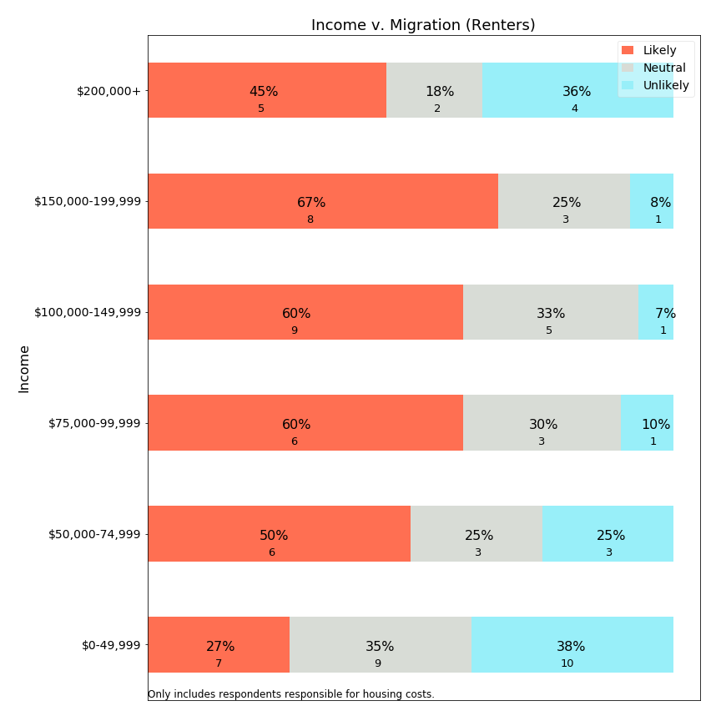

It appears that migration likelihood increases with income until $200,000, while the small sample beyond $200,000 may elect to continue renting in Lexington--though these sample sizes are quite small. At the lowest income level, renters may be much less likely to migrate, however. A review of affordable housing limits ($51,150-$78,900 for households sized 1-5), suggests that some portion of this group may reside in affordable units with rent control. Beneficial rent control could support a renter staying in place for a longer time.

**Migration and Monthly Rent (Renters)**

If low income renters forecast migration less frequently, is that pattern repeated when examining monthly rent?

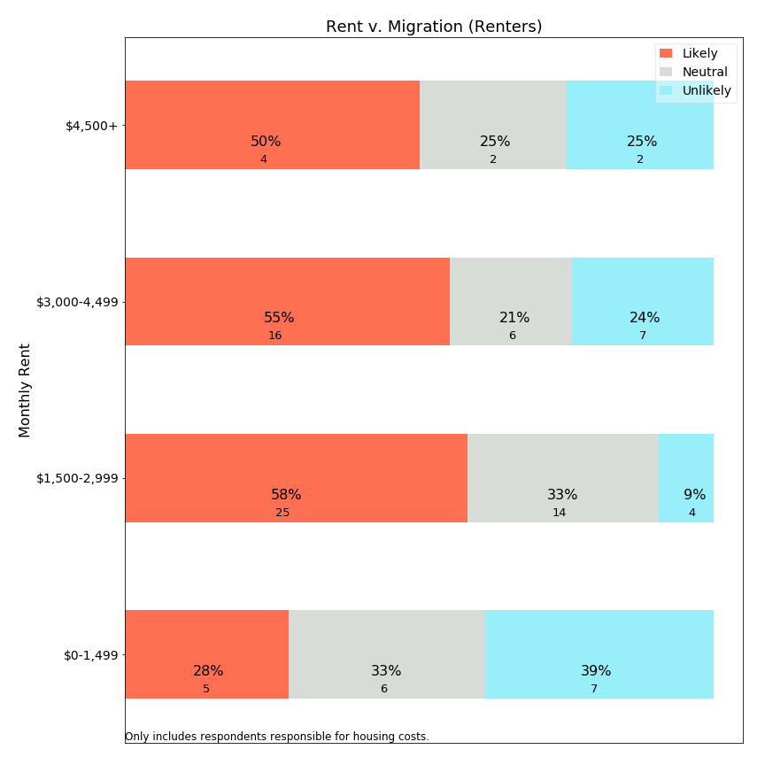

Yes, examining the relationship between rent and migration, we see a dramatic drop in migration expectations for renters with rents below $1,500/month. Because rents at this rate would typically be rent controlled (affordable) or only a room in a house, it appears that renters in affordable housing are more likely to remain in Lexington than those with higher rents. This finding is particularly interesting because we (earlier) found that housing stress is higher for those with lower rents.

One data source identifies the median rent in Lexington at $1,689. However, this seems far below market rates in general, so it is not clear if that figure is a rent controlled rent.

(source: <https://affordablehousingonline.com/housing-search/Massachusetts/Lexington> )

**Migration versus Age: Owners**

The Committee was particularly concerned with examining data which might indicate whether senior citizens are being forced to leave Lexington. Below is a visualization of age versus forecast migration:

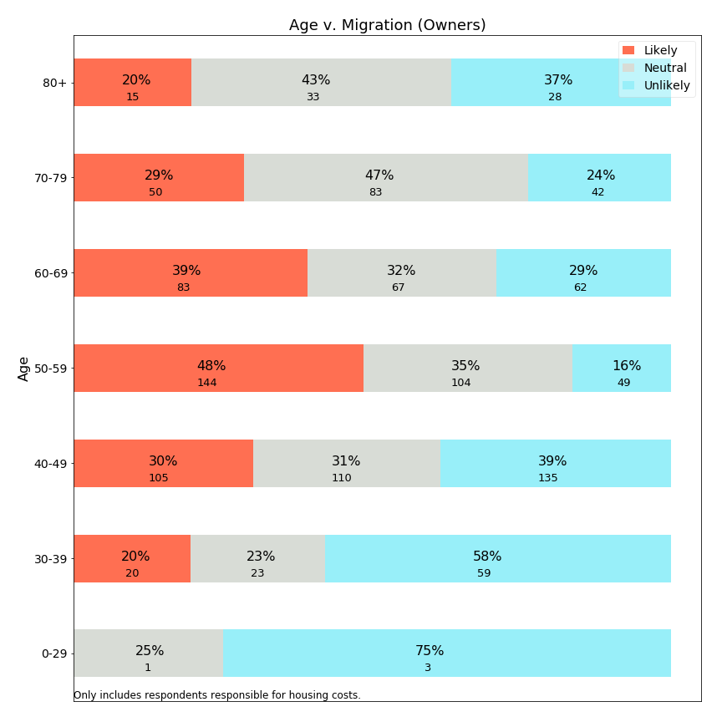

The survey identifies that owners in the range age 50-69 forecast the highest likelihood of relocating from Lexington. Especially troubling is the 50-59 age category, where about half of residents indicate high likelihood of leaving Lexington in the next 10 years. For those educating their children in the public schools, this age group represents those typically with older children who can expect to complete public school education in the next 10 years. This age cohort is also planning retirement and determining whether Lexington is a community in which they could remain through retirement.

As expressed in comments to this Committee (see Public Hearing appendix and survey open-ended responses below), many community members are frustrated that so many residents would educate their children in the public schools and then quickly leave. This 50-59 cohort is valuable to keep in town, as they would typically have the financial resources to contribute to town budgets while they continue to earn income. A residential exemption which is not well designed could have the effect of “pushing” this vital age cohort out of Lexington, or ensuring that the half who are likely to leave will leave. While the SRE is designed to benefit those in smaller homes, it is unclear whether the 50-59 year old population is living in those homes. Moreover, most means-tested implementations, like the state circuit breaker, have a minimum age of 65 and offer no benefit to the 50-59 year old respondent. Data from the survey suggests that, if Lexington has a migration “problem” among homeowners, it is across the 50-69 year age range. It is possible that neither type of residential exemption would benefit this population of mobile professionals, and could increase motivation for them to leave Lexington. Further study beyond this Committee’s work may be needed to understand migration motivations for this specific population.

**Migration versus Age: Renters**

While renters are more transient than owners, what does the survey data tell us about the relationship between age and forecast migration?

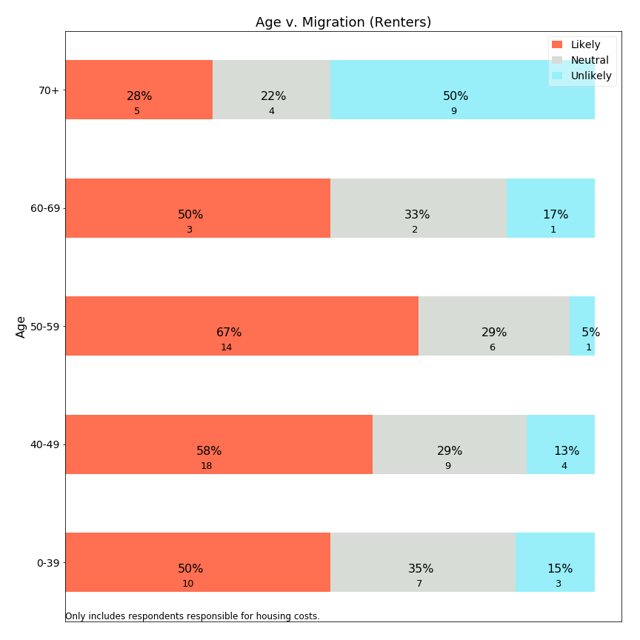

As with owners, higher forecast rates are seen for renters aged 50-59. High rates of mobility exist for all ages, except the 70+ age population which shows a decreased intention to leave.

**Migration versus Time in Lexington: Owners**

Means-tested exemptions often include a residency requirement. What does survey data tell us about the relationship between residency length and forecast migration?

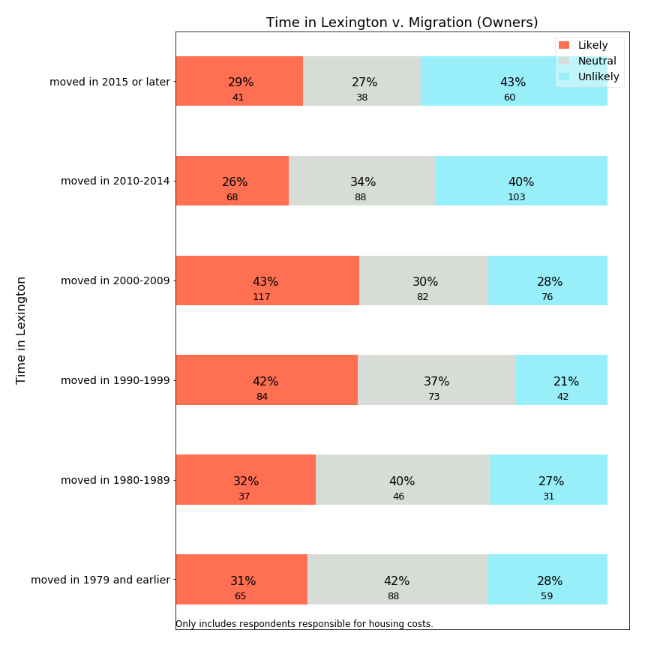

Not surprisingly, the most recent owners in Lexington forecast the lowest rate of planned migration. Those who have just arrived plan to stay. Those who entered Lexington between 1990-2009 forecast the highest rates of departure. This may correspond to the age range charts shown earlier and include many residents who may have entered Lexington for education of their children and are now considering next steps as retirement approaches.

**Migration versus Time in Lexington: Renters**

How does time in Lexington relate to migration for renters?

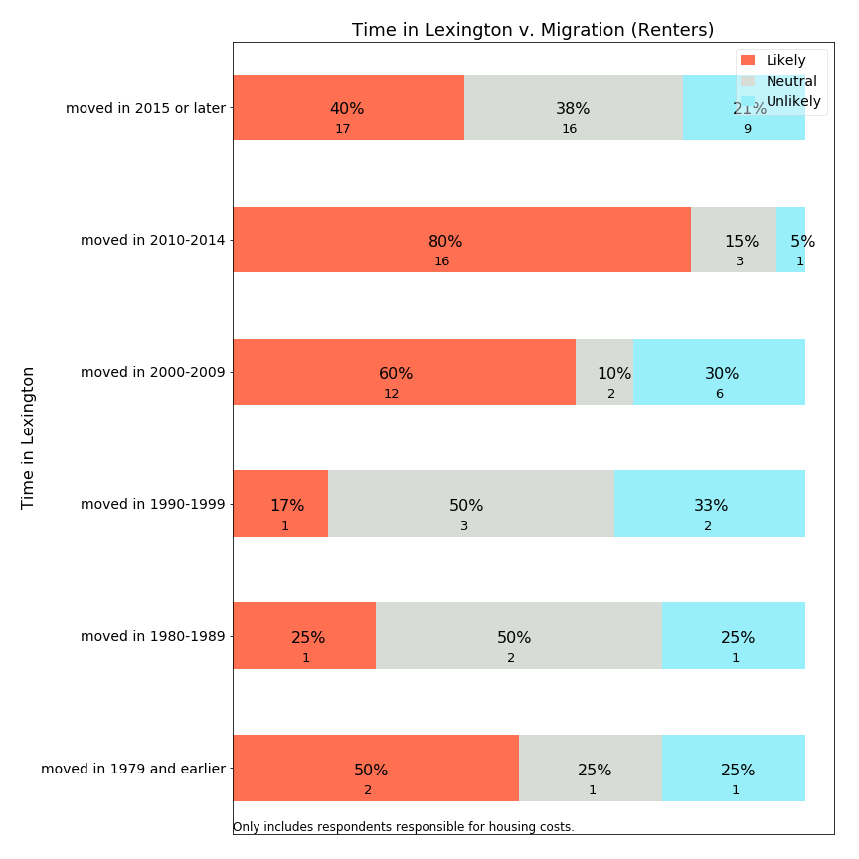

The majority of renters entering Lexington from 2000-2014 expect to leave Lexington in the next ten years. In contrast, those who have been living in Lexington for more than twenty years and are presently renters are more likely to continue living in Lexington--but long term renters are an extremely small group.

**Migration versus Means-Testing**

Using survey data, we can examine whether respondents approximately qualified for “Sudbury-like” means-testing have lower or higher tendency to forecast migration.

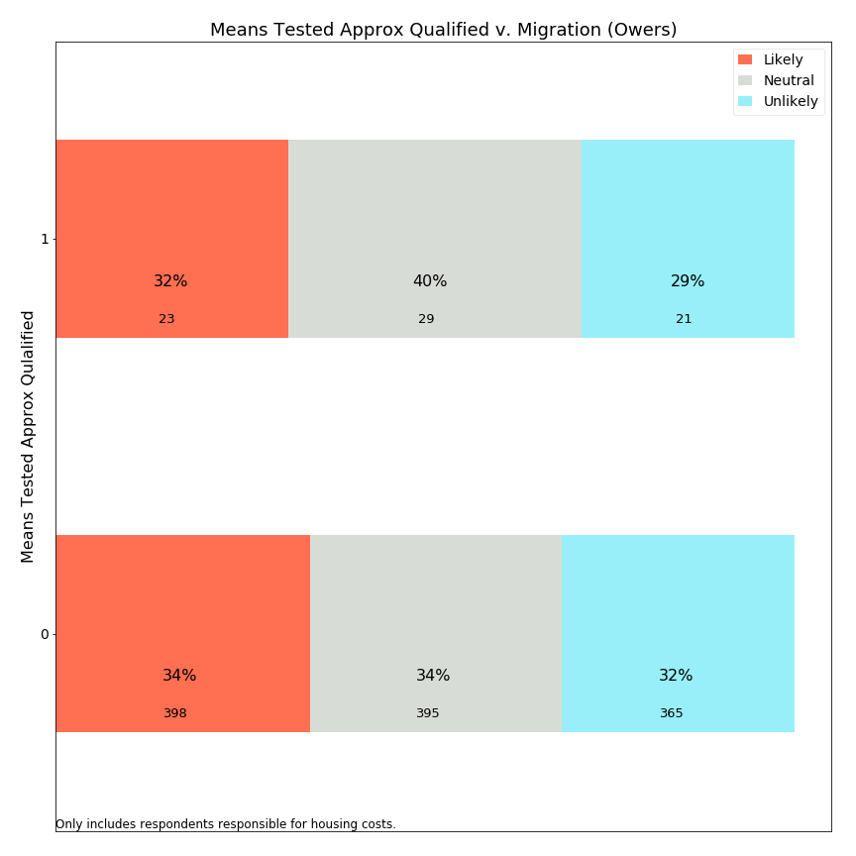

Surprisingly, the small percentage of residents meeting all means-testing eligibility criteria report migration likelihoods at identical frequencies to those who do not. It is possible that those who need the most financial assistance have depressed levels of mobility due to their financial circumstances. This suggests that the impact of a residential exemption may provide more in terms of psychological impact than migratory impact.

**Migration v. Monthly Housing Cost: Owners**

How can the survey provide insight into whether overall monthly housing costs are encouraging residents to migrate?

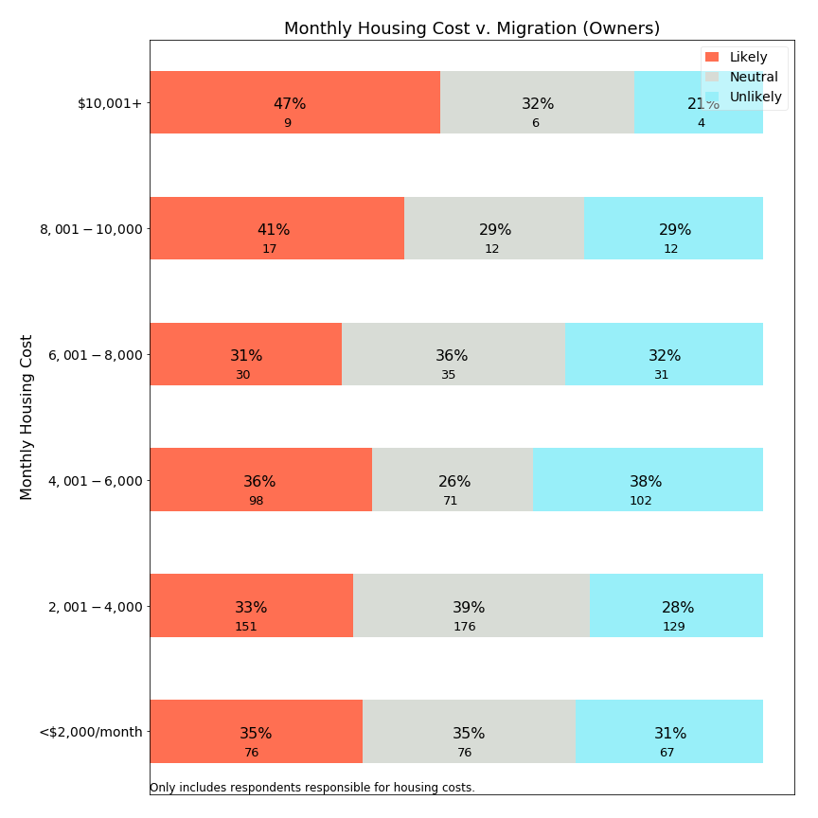

Monthly housing costs around $8,000 appear to be an inflection point, above which residents are more likely to leave Lexington and below which they are less so.

**Migration versus Property Tax Share**

If property tax share is associated with housing stress, is it also predictive of migration?

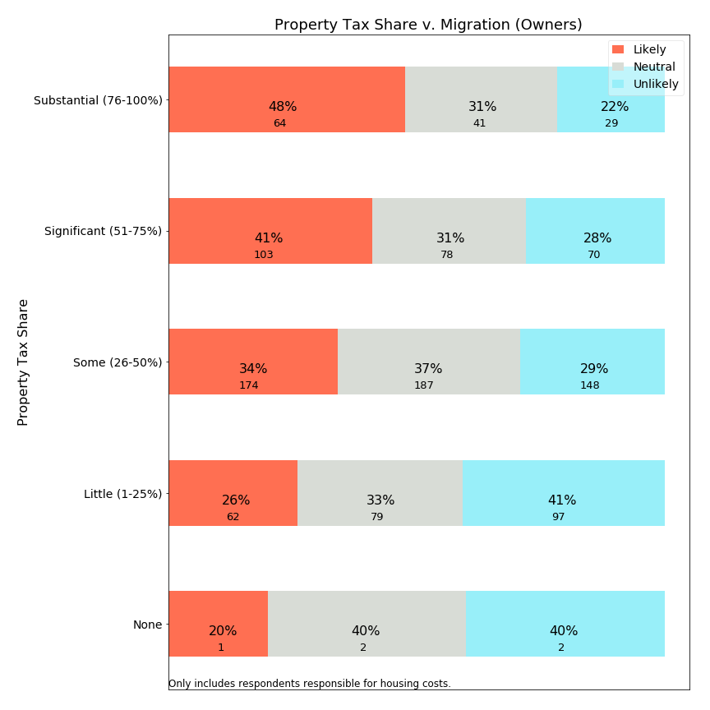

The survey data shows a fairly clear relationship between property tax share and frequency with which respondents indicate they expect to leave Lexington. Among those with under 25% of housing expenses due to property taxes, about one-quarter likely to leave. At the other end, those with more than 75% of housing expenses as property taxes indicate fewer than one-quarter expect to stay in Lexington for ten more years.

**5. Correlation Charts**

Additional charts about variable relationships.

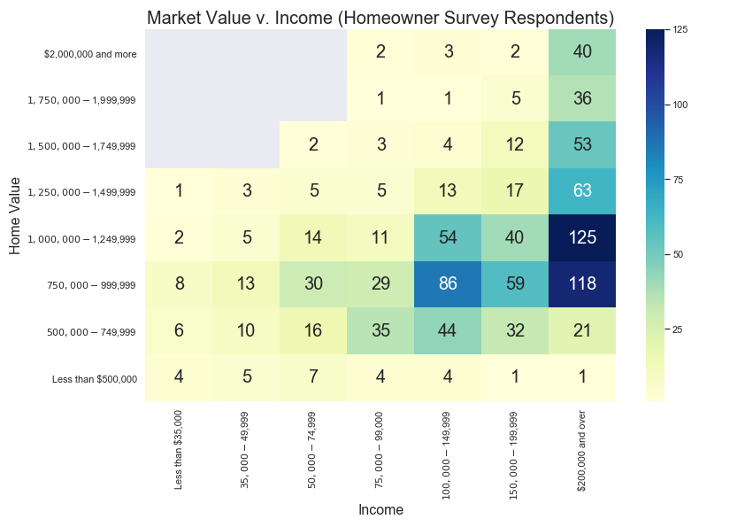

The gray boxes represent intersections which had no respondents in the survey, such as owners of $2,000,000 homes with incomes below $75,000. Because the SRE would help those below the breakpoint (around $1,200,000), a substantial numbers of respondents with incomes above $100,000 would be helped by this exemption (dark blue boxes). On the other hand, a means-tested Residential Exemption would help a subset of those on the left portion of the chart, typically below $75,000 in income (depending on program specifics). Beyond this overview chart, the Committee examined how market value versus income were broken down for different classes of owned property.

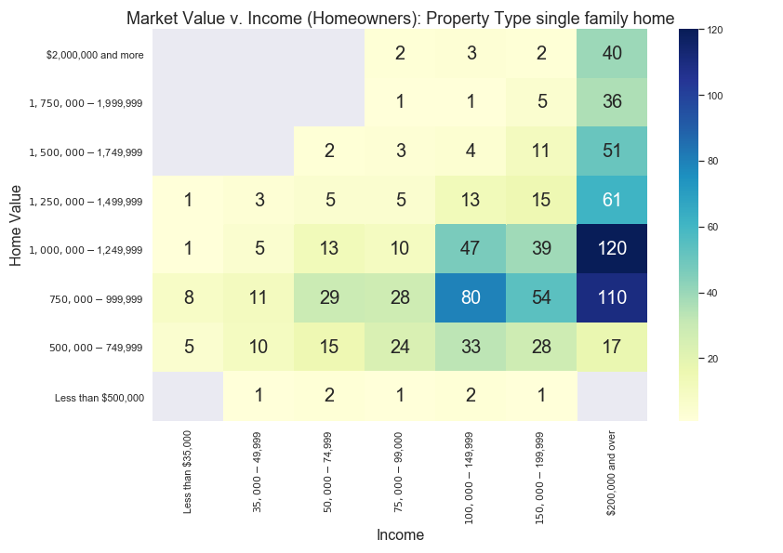

When contrasted with the prior chart, this chart shows us that many of the properties valued at under $500,000 were not single family homes. Additionally, this chart highlights that the largest group of condominium owners have properties valued between $500,000-$749,999 and are supported by incomes between $75,000-$149,999. This large cluster of owners would benefit from a SRE, as this exemption would benefit nearly 100% of condominium owners--including those earning over $200,000 income. However, this same group would typically not qualify for inclusion by any means testing guidelines.

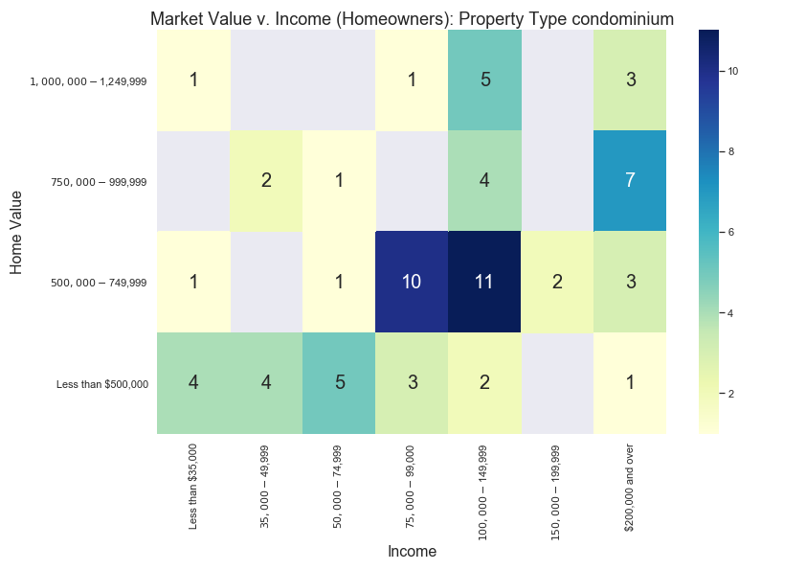

How does housing stress relate to these income and home value intersections? For this calculation, we assigned a value=1 for each respondent with significant or substantial housing stress, and value=0 for lower stress categories. The cells then show the percent of respondents reporting these “high” stress levels:

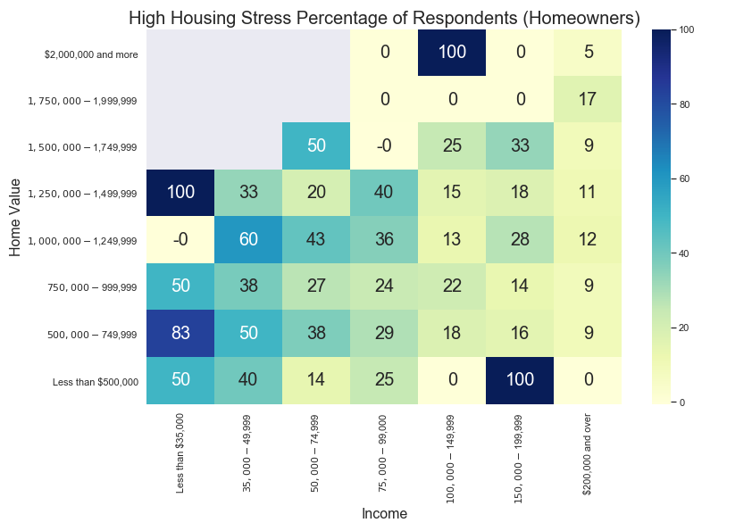

As this chart shows, high housing stress can exceed 25% of respondents for incomes below $100,000 and approach 50% of respondents incomes below $50,000. However, housing stress is not uniform for home values, as those with higher income levels do not consistently report high housing stress at any home value level.

**6. Open Response Questions**

Two open response questions were designed to solicit further information. The first open response question asked for additional information or elaboration after asking about monthly housing stress, with no prompting about property taxes. The second question was at the end of the survey, requesting any additional information respondents wanted to offer. The section below enumerates the most frequent phrases elicited in response to these questions and provides samples of comments using these phrases. There are several themes which can be summarized here:

1. High property taxes. Even for those who value the town services, the most common resident complaint was that property taxes have increased too fast and are higher than comparable towns. Concern about high property taxes was a consistent theme across most comments and keywords.
2. Town services. Some residents appreciate the services received, while others do not feel they are of sufficiently high quality for the taxes paid.
3. Capital projects and school spending. Several residents touched on these factors as drivers for high property taxes.
4. Future property taxes. Several residents mentioned future projects such as the police station and the high school, and a few suggested the town prioritize school projects and not attempt to do more than can be accomplished.
5. Our money. A few responses express resentment that town government does not treat money as their own and spend money too easily.
6. Long term residents. Several respondents lament changes to the character of the town.
7. Fixed income. Numerous respondents indicate that property taxes are too high for those entering retirement.
8. Rent or utilities. Several respondents are concerned about the cost of rent or utilities.
9. Regret about choices. Respondents, including some with children in school, retirees, and multi-generational Lexington families express regret about plans to leave Lexington.

Resident comments are published along with survey responses. The comments are in a separate data file and randomized so they will not correlate with the survey responses and maintain anonymity. Moreover, the comments were reviewed and edited with these guidelines:

Intent to keep comments intact as much as possible and substitute or redact any portion which is problematic, maintaining the spirit of openness and avoiding censorship claims.

Specific concerns to review:

* Comments which might lead to identification of a particular person making the comment. These include: specific age, employer, street name, etc.

* Comments which stereotype others while not contributing to the conversation constructively.

Where redaction or editing occurred, the specific section was substituted with square brackets (“[ ]”). For example, a year “1964” could become “196[x]” or a specific employer could be adjusted to “[employer]”. The comments reported below are post-redaction.

**Open Response Statistics and Quotes**

The first open response question asked about housing stress, which yielded the following most frequent bigrams (2-word phrases):

|  |  |
| --- | --- |
| Bigram | # occurrences |
| property taxes | 31 |
| property tax | 25 |
| affordable housing | 14 |
| stay lexington | 10 |
| town services | 9 |
| taxes high | 8 |
| living lexington | 7 |
| high school | 7 |
| tax burden | 7 |

For each bigram, we selected a sample of representative comments:

property tax or property taxes:

“Town really needs to stop spending so much money in order to stop the terrible rise in property taxes…”

“Other than that the house is too big for two people, property taxes would be second biggest reason to move.”

“I do indeed consider property taxes in Lexington to be prohibitive for seniors and retired persons.”

“Certainly property taxes are high, but we see great value from town services.”

“The combination of property taxes and the lack of new, smaller private homes in good condition, we do not anticipate being able to stay in Lexington.”

“Being able to defer property taxes helps me a great deal.”

“Property taxes are higher than my mortgage and will be the reason I move out of Lexington”

“We love Lexington but as the kids leave the nest, the fact that property taxes increase and retirement is getting closer, we are not sure we will choose to stay here due to the high taxes.”

“...please do not make the property taxes progressive, i.e. a higher percentage for larger homes. Just stop spending beyond your means. Just like the rest of us have to do.”

“My mortgage holder (my mortgage originator sold my loan to [company]) denies my participation in the town's state-enabled property tax deferral program for an arbitrary, trivial reason.”

“Not eligible for a property tax deferral (age) tax work-off covers only 10% but this becomes a moral question. These programs are a cruel hoax on senior citizens in town. Why do I have to work till I die, when others come in educate their children then leave and actually financially benefit from the capital gains on the sale of their property.”

“We have lived in town since 196[x] and will hate to leave. Seniors need a break on property tax”

“Lexington government's lack of fiscal discipline is driving property tax rates to extreme levels that will drive senior residents away and block newly established couples from living here.”

“I am concerned with the rising property tax rates and the ability of aging residents to pay. This town is always talking about diversity, but they don’t seem to be concerned at all with socioeconomic diversity.”

“We'd really like to stay in retirement but need to find a lower property tax.”

“High property tax (injustice) makes it so difficult for me to think of saving for retirement.”

“As tax reform and property tax can not be deducted and really Hope town consider lower the tax rate. use our tax money as their own money.”

affordable housing:

“Please consider providing more affordable housing for seniors.”

“Our senior citizens and young families need affordable housing. Our seniors do not need expensive elder care/senior facilities--they need small single story rental options that are TRULY affordable so they can age in the town they love.”

“there needs to be more affordable housing availability for those over 60 &/or retiree's without children to help to maintain the diversity of our community.”

“It is appalling that people are buying houses here and not living in them, using them for tax shelters, or buying houses and letting people live there to attend the schools. There isn't enough affordable housing in town, and it impacts our neighborhoods and the makeup of our town.”

stay lexington:

“I hope that it helps to allow taxes to be lowered so I can stay in Lexington”

“We can't afford to stay in Lexington like our parents did.”

“We won't be able to afford to stay in Lexington when we retire.”

“Lexington Town Taxes are prohibitively high! As we age, it is not economically viable for us to stay in Lexington, a town in which we have rented, and then owned a Town House and now a Single Family home! Town finances need to be managed better before passing the burden to the Town residents.”

“I wish they will be a way … to stay in Lexington in my home forever once my kids outgrow the school system .. as an [foreign country] immigrant and US Citizen this is my home and the only one I can go back when I retire ...due to the political situation of my original country ... I wish I could financially be able to afford it but even with savings, Lex taxes are crazy high …”

town services:

“Besides the school system, we don’t see strong value for our taxes reflected in other town services. It is motivating us to move when our kids complete school in this area.”

“We are fortunate to have many excellent town services”

“Do not implement a residential exemption that simply shifts the tax burden to other residents. Cut town services particularly schools to make up for any shortfall created by any residential exemption.”

“We are concerned with the constant capital projects in the town related to town services, fire station, Cary Hall, DPW garage, community center, in a time where we have and have had multiple school projects at the same time.”

taxes high:

“Property taxes are high, but we do receive a lot of benefits.”

“Certainly property taxes are high, but we see great value from town services.”

town taxes:

“I do hope the survey will be used to find ways to stop increasing town taxes. People move out of Lexington because of the taxes, there must be a way to decrease the spending so we don't have to increase taxes.”

“We love living in Lexington and all the town services, community organization and especially the public schools. We understand that takes money and have no issue with the level of town taxes. However, for the money we are paying, we are disappointed in what we're hearing so far of the math program at Harrington Elementary.”

living lexington:

“Cost of living in Lexington is incredibly high, and it's very depressing to watch all the smaller and more affordable homes in our neighborhood torn down”

“Many people in the town are upset about the rising cost of living in Lexington, particularly the rising property taxes. Most people are not aware of the 32% increase that is locked in over the next 10 years based on official Town projections, nor are they aware that this increase does not include any new taxes to fund the $300 million+ (Town estimate) replacement high school that is in early planning stages.”

“We hope to age in place because we love living in Lexington. However, the taxes may make that prohibitive.”

“Taxes make it impossible to retire and stay in lexington. I was born in 195[x] in Lexington and I am 3rd generation living in lexington.”

“i love living in lexington-think it is a great well run town”

high school:

“General concerns about rising taxes and large-scale projects (high school, fire station, new children's place, etc) and whether all options are being considered”

“Tax burden to Lexington residents is to high. Tax dollars should be spent on the need for an new high school and cut everywhere else.”

“The schools have become so large and overcrowded, there are no opportunities for kids to participate in any extra-academic/extracurricular activities: 150-200 kids show up to compete for a spot in a school team with 10 kids. The town needs to do something to discourage this crazy expansion of the school system.”

“Please look for ways to have Lexington a lifetime town, not a move-in with preschool kids, move out when the kids graduate from high school.”

“Lexington needs to control spending and be more diligent regarding capital expenses as most families move here for schools and re-building the two middle schools and high school should be the ONLY priority of major projects for the town next ten years.”

tax burden:

“The tax burden is significant and becoming more so. Why do we usually seem to choose the deluxe version when a lesser version is ample, e g. the community center, design for new police station.”

“Some towns such as Cambridge give tax breaks to owner-occupied dwellings, and others have enough tax base (commercial and industrial firms) to make the tax burden fall more lightly on homeowners. We live in a neighborhood where as homeowners of a 2 bedroom bungalow we pay considerably more taxes than the million dollar restaurant across the street.”

“Large families move in for the school system, but their local taxes don't pay the extra cost of putting their children through the schools here. The tax burden gets placed on empty-nesters and retirees.”

At the end of the survey, respondents were asked to share additional comments. These were the most frequent bigrams:

|  |  |
| --- | --- |
| Bigram | # occurrences |
| property taxes | 58 |
| property tax | 39 |
| taxes high | 27 |
| real estate | 23 |
| estate taxes | 18 |
| years ago | 13 |
| fixed income | 11 |
| tax high | 9 |

property taxes or property tax

“We pay almost $3700 four times a year for property taxes. Compared to other towns we talk to friends about they get almost twice the services we do here.”

“My husband is dead, and my house is paid off. I’d love to stay in Lex, but I am paying ‘full freight’ and utilizing few services. I looked to see if there were any deals for my in the area of property taxes ($18,000). I didn’t qualify. I’m not Section 8 level. I sold my house”

“It bothers us that property taxes are less in other similarly situated towns with equivalent services.”

“Do have concerns about rising property taxes, especially with new federal tax laws”

“Thinking about retirement. The cost of property taxes will be prohibitive.”

“Taxes keep increasing and even when the mortgage payments will be done we will still pay nearly $1200 per month for property taxes. This becomes an issue as we age and retire”

“My property taxes consume 33% of net income”

“Our property taxes are sky high and keep going up. Our youngest is going to be done with public school soon and we are talking about moving to a town with lower property tax rates”

“In 2004 my husband and I bought our house in Lexington and our property taxes were $3000 a year. Now they have almost tripled and we are retired [living on retirement savings] and Social Security. We really love Lexington and believe in spending for good schools, etc., but it may not have been smart for us to move here in retirement.”

“Too many rental units with children attending public school which makes the school overcrowded and put stress on higher property taxes”

“After kids are done with Lex public schools, we would consider moving out of town because of high property taxes. Town is wonderful and provides many great resources but wished there were a bigger business tax base so that the burden of taxes doesn't come upon residential property owners.”

“My husband is still working at age 7[x] but when he retires I am quite concerned about our property taxes. We have an adult child with special needs living with us and cannot downsize or move very easily.”

“property taxes have >TRIPLED in 15 years. NOT sustainable!”

“Half of my military retirement pay goes to property taxes. I'm retired.”

“Our property tax has nearly doubled in the past 5 years and will likely double again once the new levies, plus the upcoming levy for the new high school, are added. We are seriously considering moving to another town where the property taxes are more fair and reasonable.”

“With our current income and spending, our budget is borderline break even if not in the red, and ANY increase in housing costs (mainly property taxes, as these are generally the only cost that goes up every year) digs us further in the hole.”

“My property taxes are 1/10th my income. My estimated income tax is also 1/10 my income. By the time I'm done paying my bills (401K, retirement, electric, etc.), I end up with $300 to $500 a month to live on. For everything. The ironic part is that I'm too young for senior discounts (only 6[x]) and I make too much to qualify for low income. I haven't bought any new clothes in approximately 5 years.”

“We have conservation land as a part of our back-yard which we never use. It really hurts to pay property tax on that area. The property taxes are increasing way too fast than the salary increase at our workplace!”

“property taxes are too high! runaway spending in the town!”

“Our house is paid, so we don't stress about total costs, but we do stress about rate of increase in our property taxes.”

“The property taxes of $8,000/year for retired couple, former [public employee], is very HIGH! Our house is 1300 sq ft. One bathroom. Why are these taxes so high?”

“Last spring I ran out of heating oil, the property tax bill pushed out the refill until early summer. This coming year I will drop my homeowners policy because there is no room left in my budget with the increases.”

“Property tax too high when we are not using school system. We may decide to move to town with lower property tax”

“The property tax is too high due to substantial special education cost.”

“Although I'm entirely eligible for Lexington property tax deferral program, my mortgage holder refuses to allow my participation owing to legal technicalities in the structure of the program that the bank says inconveniences them.”

“When we moved to Lexington 21 years ago, our property tax was around $4600. Now it's over $12,000, and still going up faster than inflation. We won't be able to fully retire here.”

taxes high or tax high

“Town taxes are too high and spending is questionable, e.g., first fixing the old high school a few years back for $60M, and now deciding to build a new one for $200M.”

“The taxes are too high. The town spends money at too high a rate”

“Have adequate financial resources to pay bills. Would rather taxes weren't so high--and don't like to think about how high they are. But also understand that taxes are necessary for services.”

“lexington has high costs with very little services or amenities that are useful to all. it is not the same town I grew up in!”

“taxes are so high that I can't keep up with them.”

“high taxes--house assessment increase was astronomical”

“My feeling is that the assessment on our house is too high and I feel it was manipulated to increase the tax bill. Our house is old, small and in poor condition. If the taxes were lower, I would be able to fix the areas of the house that need to be repaired.”

“the taxes are crazy high”

“There have been 9 out of 10 overrides in the past 10 years. Taxes are too high even with the evaluation on all the McMansions. Negotiations on union contracts is a big problem. Where are the cost controls?”

“It is costly living in lexington, mainly due to high taxes.”

“Taxes are very high, largely because of school spending.”

real estate or (real) estate taxes

“Must move out of town due to high real estate taxes (on limited income).”

“Smaller real estate options to "age in Lexington" are few. I grew up in Lexington, graduated from the school system. My family has been here for 75 years. My view is that Lexington has focused on replacing small homes with McMansions purchased by people who want the school system for their children with no intention of making Lexington "home."”

“the real estate taxes keep going up and we are not sure we will be able to continue to live in this town--the town is spending vast sums of money to replace schools and other public buildings-- money that the town does not have and wealthier people in town keep voting for overrides”

“My attitude is that if the people of the town care about education and their kids, they care about the town in general. I feel this way, even though I have no children. I have taught in the town for [x] years. The real estate taxes are getting to us, though, as we enter our 70s.”

“expensive real estate taxes as Widow choosing to stay in familiar environment!”

years ago

“We pay $5700 a month for rent and there are only 2 adults and one high school student. It's obscene. We moved into this house 6 years ago and the rent was $4200 but it's gone up every year.”

“Our taxes have more than doubled since we've moved here 18 years ago. We're both in our 70's and plan on staying in Lexington, but worry about affording our taxes as the years go by.”

“Taxes have been on a steep increase since we moved here 4 years ago, and I believe they will continue to rise at a steep rate due to town construction on public buildings. It may become unaffordable in the near future if the town continues to grow/build at this rate.”

“Our taxes on an unrenovated, 3 bed, 1 bath, 1200 sq ft cape represent more than 1/3 of our total housing cost--and this on a house we bought 5 years ago for $500k with a conventional mortgage and downpayment. The taxes will cause us to move even before we have our child in school.”

“Our high taxes are an issue for many retirees. With new schools, fire and police buildings and other additional large expenditures happening, we and others are worried that we will be forced to move to a town with lower taxes. We do not want that to happen to us.”

“When we moved to Lexington 21 years ago, our property tax was around $4600. Now it's over $12,000, and still going up faster than inflation. We won't be able to fully retire here.”

fixed income

“I worry that Lexington spends money without any concern for those on fixed incomes e.g. Purchase and demolition of Armenian School on Pelham.”

“Real estate taxes are too high and are making it hard for fixed income retirees to remain in this community.”

“I also have elderly parents living in this town on a fixed income and the taxes we pay here are outrageous. I only stay in this town because my parents do not want to move and my youngest has 3 more years of high school.”

“Retired, on fixed income. Property taxes are very high. Mortgage is paid off.”

”Property taxes are high for those on fixed incomes. Cambridge, for example, provides both a residential tax credit and an elderly tax credit.”

“As seniors raising elementary aged children, we will be forced to move out of town as soon as they complete their education here. We will not be able to afford staying here on a fixed income. Even if we could, the housing now available would not be appropriate for aging in place.”

“I don't think that all fixed income qualifying residents know that they can defer their RE taxes at an extremely low interest rate, until their property sells. How can we get this knowledge of this very generous town benefit to every financially struggling resident who qualifies?”

“Once we retire, we are very concerned with our qtrly tax bill of $4,000. Candidly, after 33 years, we may decide to sell and find a community with Real Estate Taxes in the $6 to $8 K range, annually. We've loved Lexington but may be to expensive on a fixed income basis.”

**7. Statistical Analysis of Housing Stress and Predicted Migration Decisions**

Prior analysis sections merely visually illustrate relationship between variables. While such an approach is easily comprehensible, it is an incomplete characterization of variables which are driven by multiple variables. Policy makers should be interested in comparing the strength of contributing factors when multiple are present, as well as quantifying the change in dependent variables which might be expected with a change in policy. Statistical analysis offers an approach to estimate these factors.

Two questions merit statistical analysis:

* What contribution does property taxation make to reported housing stress?
* What contribution does property taxation make to self-reported, predicted migration decisions?

Household stress was surveyed using a categorical response question with five answers of increasing stress, reflecting an implied ordinal scale. Statistical estimation would best use of one two approaches:

* Treat household stress as a continuous variable with five point estimates, and use **ordinary least squares** (OLS) to predict changes on a continuous scale. This approach is limited because survey responses are truncated at a minimum and maximum value but a statistical model fits to a line.
* Use an **ordinal logistic** model to reflect latent levels of stress with estimated thresholds which are associated with respondents selecting from five levels. This method allows the thresholds to exist independently of one another, but has the disadvantage that confidence interval estimation is more complicated.

We used OLS estimation first, because it easily estimates statistical significance, thereby allowing less significant variables to be omitted in model iterations. We initially limited response inclusion to cases where the respondent reported both owning a home and being responsible for housing costs (1239 of 1475). Of these, 1208 provided answers to the housing stress question, and 914 answered all statistically relevant questions.[3] After selecting appropriate parameters, we tested our model tested against an ordinal logistic model. The ordinal logistic model test did not provide insights and is not included here.

To run analyses using the migration likelihood responses, we recoded the response categories as follows:

* Definitely Not: 0
* Unlikely: 1
* Have not considered (or) Undecided - Possible: 2
* Likely: 3
* Definitely: 4

We elected to combine two codes which are seemingly neutral into code 2 as neither response lends itself to being more or less likely than the other, and both belong somewhere in the middle of this scale. The end result is that the relocation dependent variable is an ordinal variable with five levels (0-4), with higher levels indicating higher forecast propensity to migrate out of Lexington.

An OLS model predicting housing stress has a R2=0.2, and seven significant explanatory variables. With this model, we can estimate the impact of a residential property tax exemption on housing stress levels as follows: Assume a household has property taxes of $10,000 per year (roughly a $700,000 assessed value). For a range of monthly housing expenditures ($1000, $1500, … $4000) imagine that the property tax were reduced by $5000 (50% would be a very generous tax exemption) and calculate the change in monthly housing costs and property tax % of monthly housing. Using these changes and the coefficient, estimate what happens to the level of housing stress. Not surprisingly, the findings indicate that the greatest impact of a $5000/year property tax reduction will be felt in households having the smallest (prior) monthly housing expenditures and therefore the greatest (prior) percentage of housing expenditures related to property taxes. A bit more surprising may be that the model indicates only a modest adjustment to stress with significant changes in property taxes. However, this modest relationship may be due to the fact that numerous other factors contribute to housing stress beyond the effect of property taxes.

|  |  |
| --- | --- |
| Prior Monthly Housing | Effect of 50% reduction of property taxes |
| $1,000 | -0.40 |
| $2,000 | -0.23 |
| $3,000 | -0.18 |
| $4,000 | -0.15 |

The model predicting migration forecast has an R2=0.12. While it seems that housing stress is among main drivers, and there may therefore be a direct and indirect property tax link, the statistical relationship is very weak. We can estimate that a stress change of 1.0 may be related to a 0.28 change in the scale for likelihood of moving, but as the 1.0 stress change is not estimated to occur through tax exemptions, it appears that this study does not find evidence that tax policy would directly affect migration. (For the non-statisticians, this does not mean that tax policy changes have no effect; it merely means that no material effect is *identified* with the data from this survey.)

Because property taxation impacts household stress, and the latter impacts migration decisions, we have an “endogenous variable” problem which makes estimation of the impact of property taxation on migration more difficult. We tried using a third model to predict migration likelihood in which housing stress was excluded from the independent variables, since it may mask direct relationships between property taxes, household costs, and propensity to move. As the model overview below describes, the relationship appears largely consistent with the prior models. A weak model exists for migration likelihood, and a large change in property taxes and housing costs for an individual could result in a change in propensity to move, but not enough to change the distribution of responses among this survey’s categories.

[TBD: Add interpretation of these models or summarize]

**Statistical Models**

OLS Model for Stress:

====================================================================  
Model: OLS Adj. R-squared: 0.200   
Dependent Variable: StressCode AIC: 2591.0511  
Date: 2018-11-25 21:39 BIC: 2629.5937  
No. Observations: 914 Log-Likelihood: -1287.5   
Df Model: 7 F-statistic: 33.59   
Df Residuals: 906 Prob (F-statistic): 1.05e-41   
R-squared: 0.206 Scale: 0.98833   
--------------------------------------------------------------------  
 Coef. Std.Err. t P>|t| [0.025 0.975]  
--------------------------------------------------------------------  
Income914 -0.0048 0.0004 -10.8862 0.0000 -0.0057 -0.0039  
MarketValue914 -0.0460 0.0094 -4.9003 0.0000 -0.0644 -0.0276  
Age914 -0.0136 0.0036 -3.7911 0.0002 -0.0207 -0.0066  
MonthlyHousing914 0.1538 0.0197 7.7935 0.0000 0.1151 0.1926  
HouseholdSize914 0.1602 0.0404 3.9631 0.0001 0.0809 0.2396  
PropertyTaxShare914 0.0080 0.0016 5.0903 0.0000 0.0049 0.0111  
AgeIncome914 -0.0001 0.0000 -2.1343 0.0331 -0.0001 -0.0000  
One 1.4879 0.0377 39.4321 0.0000 1.4138 1.5619  
--------------------------------------------------------------------  
Omnibus: 15.853 Durbin-Watson: 2.031   
Prob(Omnibus): 0.000 Jarque-Bera (JB): 10.355  
Skew: 0.115 Prob(JB): 0.006   
Kurtosis: 2.532 Condition No.: 1729   
====================================================================  
* The condition number is large (2e+03). This might indicate  
strong multicollinearity or other numerical problems.

Monthly housing costs, household size, and property tax share all increase reported housing stress.

Age, income, market value, and age*income all decrease reported housing stress.

Note: Variables with suffix 914 are mean-adjusted version of the 914 original survey code responses. The new variable is obtained by subtracting the mean from the original 914 observations to create a new variable with mean=0.

OLS Model for Relocation:

==================================================================  
Model: OLS Adj. R-squared: 0.120   
Dependent Variable: RelocationStat1 AIC: 2671.5200  
Date: 2018-11-25 21:49 BIC: 2695.6091  
No. Observations: 914 Log-Likelihood: -1330.8   
Df Model: 4 F-statistic: 32.15   
Df Residuals: 909 Prob (F-statistic): 4.34e-25   
R-squared: 0.124 Scale: 1.0828   
------------------------------------------------------------------  
 Coef. Std.Err. t P>|t| [0.025 0.975]  
------------------------------------------------------------------  
Age914 0.0112 0.0029 3.9053 0.0001 0.0056 0.0169  
StressCode 0.2861 0.0315 9.0718 0.0000 0.2242 0.3479  
PropertyTaxShare914 0.0052 0.0016 3.2042 0.0014 0.0020 0.0083  
AgeIncome914 0.0001 0.0000 4.8003 0.0000 0.0001 0.0002  
One 1.7572 0.0607 28.9288 0.0000 1.6380 1.8764  
------------------------------------------------------------------  
Omnibus: 19.328 Durbin-Watson: 2.027   
Prob(Omnibus): 0.000 Jarque-Bera (JB): 10.633  
Skew: -0.017 Prob(JB): 0.005   
Kurtosis: 2.473 Condition No.: 2672   
==================================================================  
* The condition number is large (3e+03). This might indicate  
strong multicollinearity or other numerical problems.

Age, stress, property tax share, and age*incoe are all positively correlated with forecast of relocation. The overall r^2=0.12, so the relationship is fairly weak.

The strongest relationship is between stress and forecast relocation. A one level increase in stress corresponds roughly to a 0.3 level increase in propensity to move.

Property tax share not only directly impacts propensity to move, but also indirectly affects through its impact on stress.

Therefore we find that property tax burden is related to forecast relocation, however the effects appear in total to be small and most impactful on those for whom property taxes constitute the preponderance of monthly housing costs.

OLS Model for Relocation (without using Stress as a predictor):

===================================================================  
Model: OLS Adj. R-squared: 0.063   
Dependent Variable: RelocationStat1 AIC: 2729.8131  
Date: 2018-11-25 22:24 BIC: 2758.7201  
No. Observations: 914 Log-Likelihood: -1358.9   
Df Model: 5 F-statistic: 13.31   
Df Residuals: 908 Prob (F-statistic): 1.53e-12   
R-squared: 0.068 Scale: 1.1529   
-------------------------------------------------------------------  
 Coef. Std.Err. t P>|t| [0.025 0.975]  
-------------------------------------------------------------------  
Income914 -0.0020 0.0004 -4.4257 0.0000 -0.0028 -0.0011  
Age914 0.0047 0.0034 1.4057 0.1601 -0.0019 0.0114  
MonthlyHousing914 0.0537 0.0184 2.9163 0.0036 0.0175 0.0898  
PropertyTaxShare914 0.0070 0.0017 4.1991 0.0000 0.0037 0.0103  
AgeIncome914 0.0001 0.0000 4.3321 0.0000 0.0001 0.0002  
One 2.1881 0.0407 53.7323 0.0000 2.1081 2.2680  
-------------------------------------------------------------------  
Omnibus: 39.032 Durbin-Watson: 2.005   
Prob(Omnibus): 0.000 Jarque-Bera (JB): 17.049  
Skew: 0.041 Prob(JB): 0.000   
Kurtosis: 2.336 Condition No.: 1604   
===================================================================  
* The condition number is large (2e+03). This might indicate  
strong multicollinearity or other numerical problems.

PropertyTaxShare914 has values as follows:

-4.811816 418  
-29.811816 203  
 20.188184 189  
 44.188184 100  
-42.811816 4

(This occurs because it is a mean=0 adjusted version of PropertyTaxShare)

A category jump on this scale is therefore about 20 points. So a full category jump (20) multiplied by the coefficient 20*0.007 = 0.14; so it translates to about 1/6th step in the predicted propensity to move scale. This finding is roughly consistent with the impact of property taxes on stress found in the first relationship. It is a weak relationship with limited substantive impact.

**8. Survey Response Summary**

This section shows the response frequency for the questions asked in the survey. Each chart shows the absolute number and percent of respondents selecting each response. The open response questions are summarized in an earlier portion of this appendix.

**Section 1: Town Services**

In the past 12 months, has any household member done the following?

Q1. Visited the Community Center

Lexington recently developed a community center at the intersection of Route 2A and Massachusetts Avenue, with function rooms and multi-generation activities.

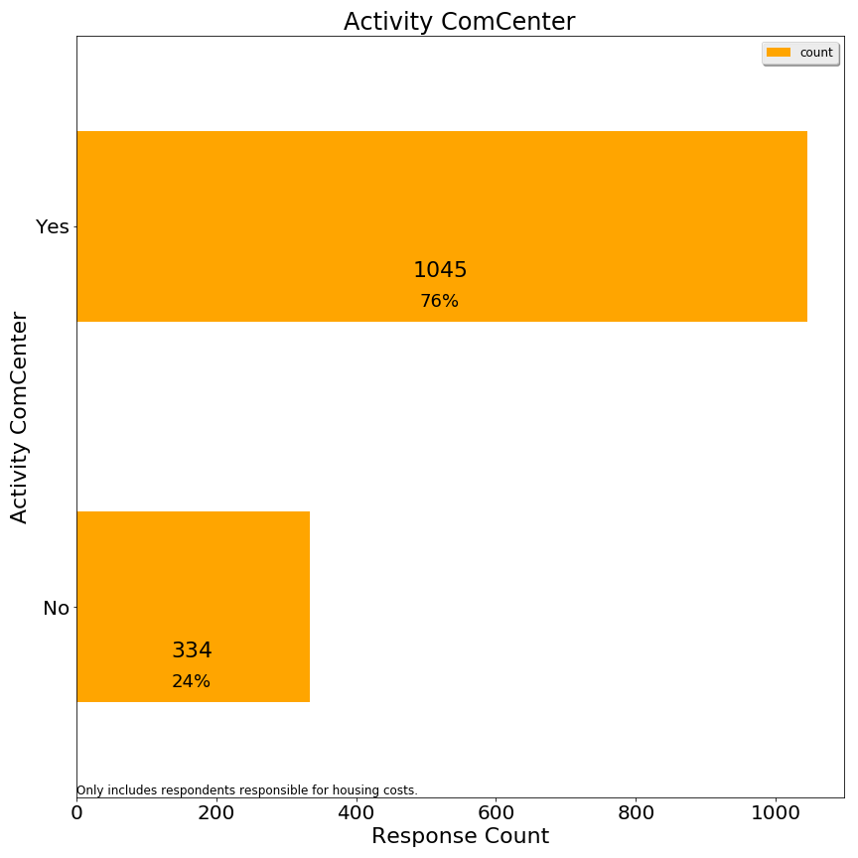

Q2. Used town swimming facilities

Lexington has an outdoor complex for swimming and splashing, as well as a beachfront style pond at the Old Reservoir.

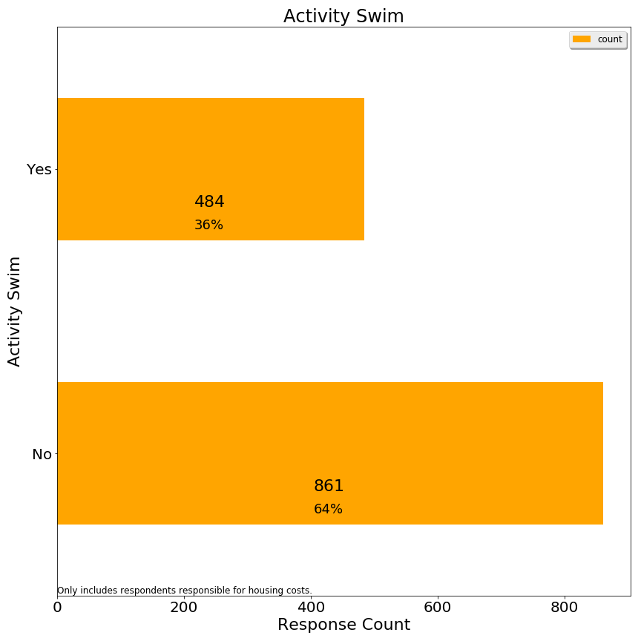

Q3. Used town recreational fields or courts

Lexington has numerous outdoor fields and tennis courts, some of which are lit for night play.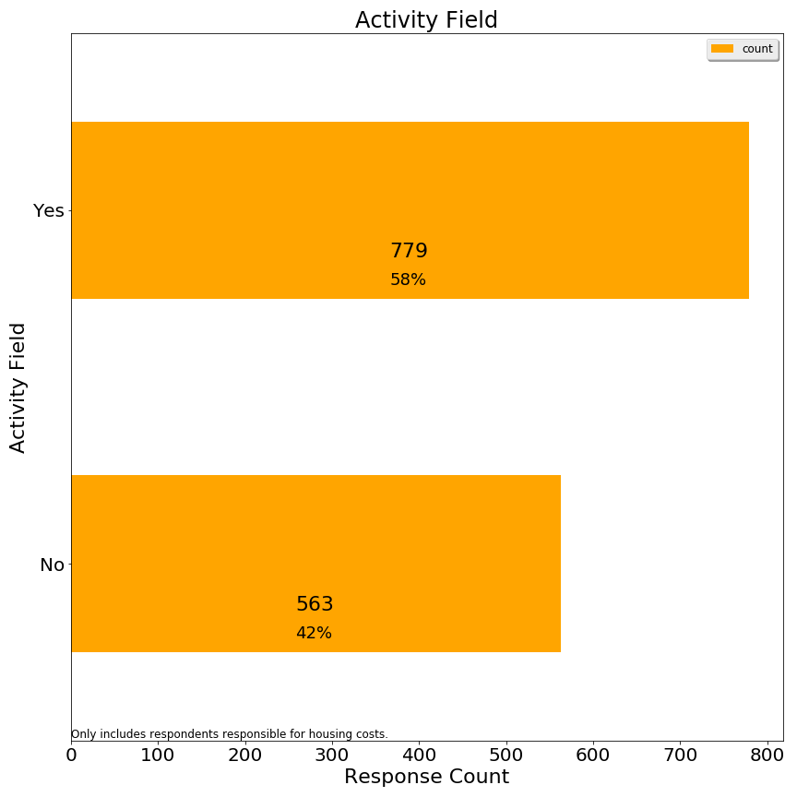)

Q4. Used Pine Meadows golf course

Lexington owns a public 9-hole golf course near route 128.

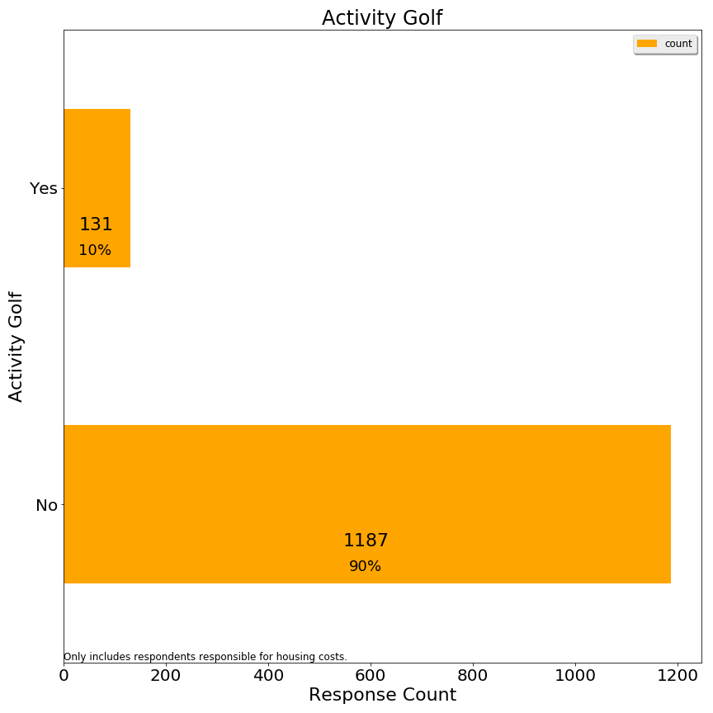

Q5. Used a school or neighborhood playground

Lexington has neighborhood playgrounds and school playgrounds, both of which are open to families without children in public schools.

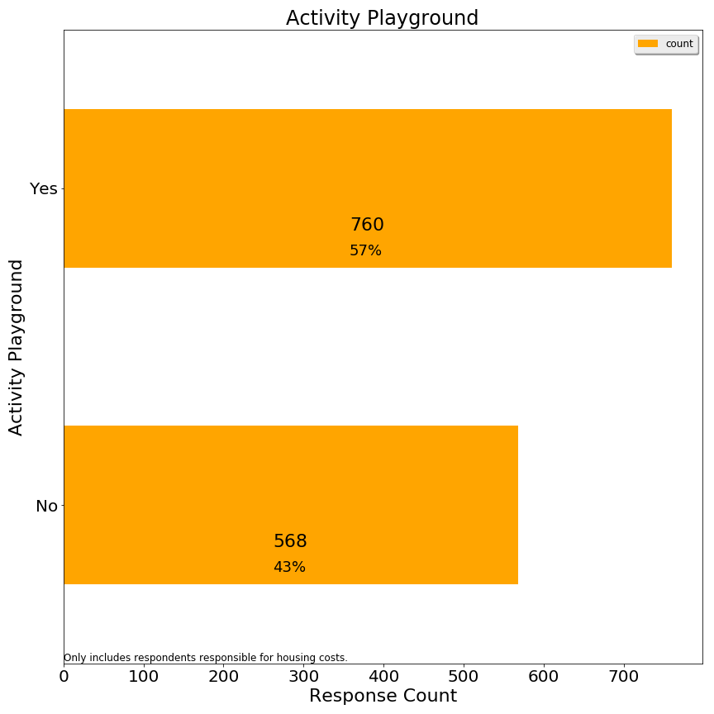

Q6. Used the Minuteman Bikeway

The Minuteman bikeway runs through Lexington from Arlington to Bedford.

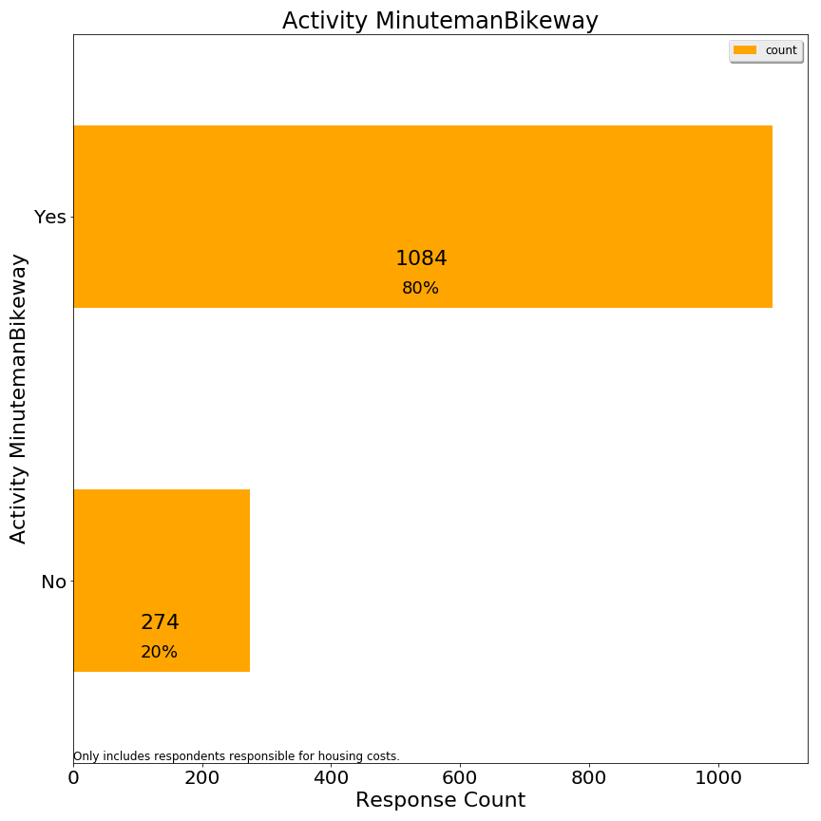

Q7. Used Lexpress bus

Lexpress is Lexington’s local bus service.

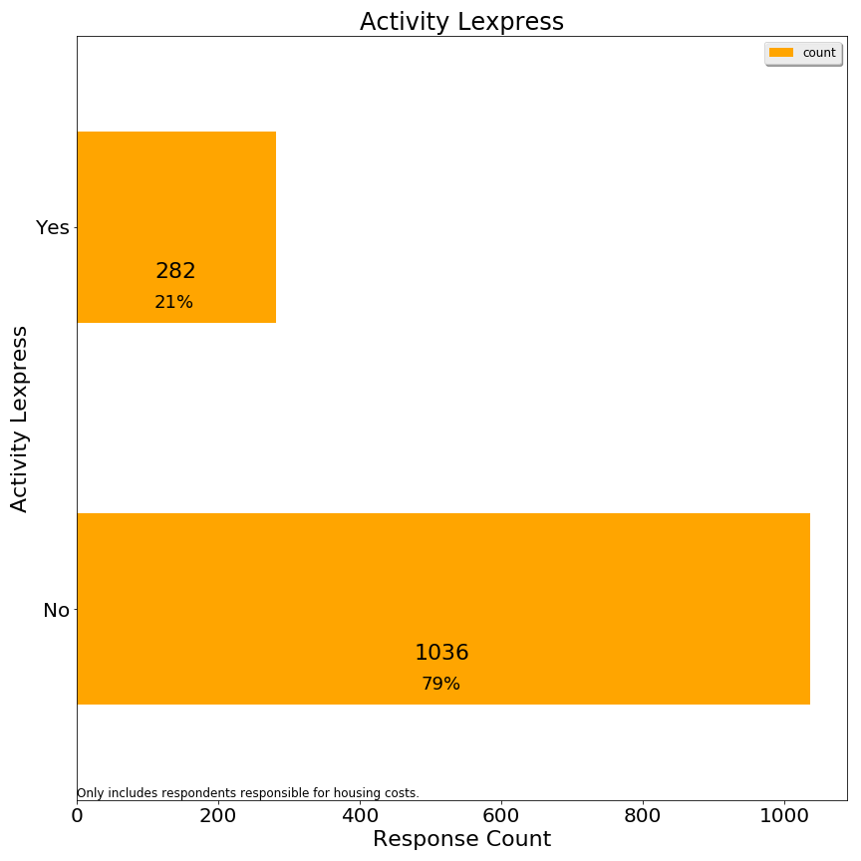

Q8. Visited Lexington conservation areas

Lexington prides itself on the large % of land dedicated to conservation.

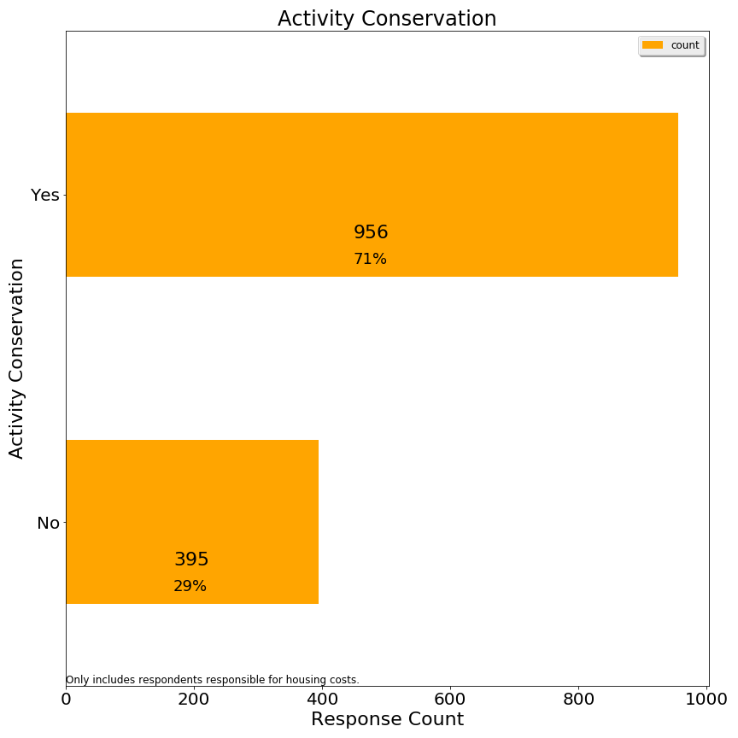

Q9. Directly received fire or police services

Lexington has 1 police station and 2 fire stations, facilities targeted for capital improvements.

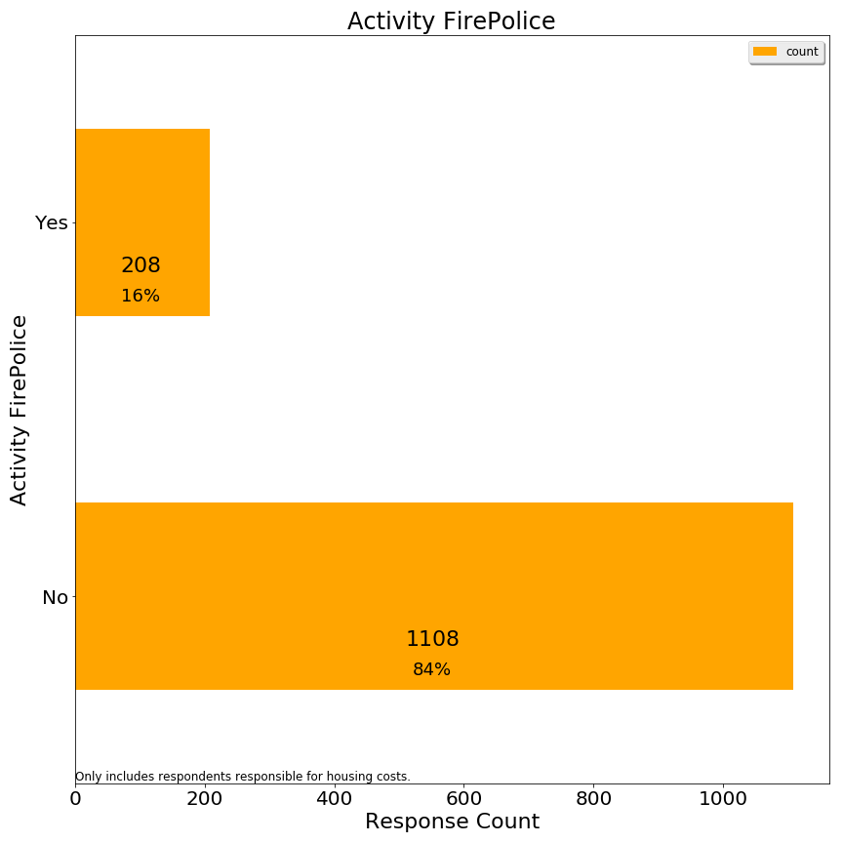

Q10. Attended Lexington public schools

Lexington public schools are a prime reason for residents to move to Lexington--to such an extent that enrollment has outpaced classroom facilities. 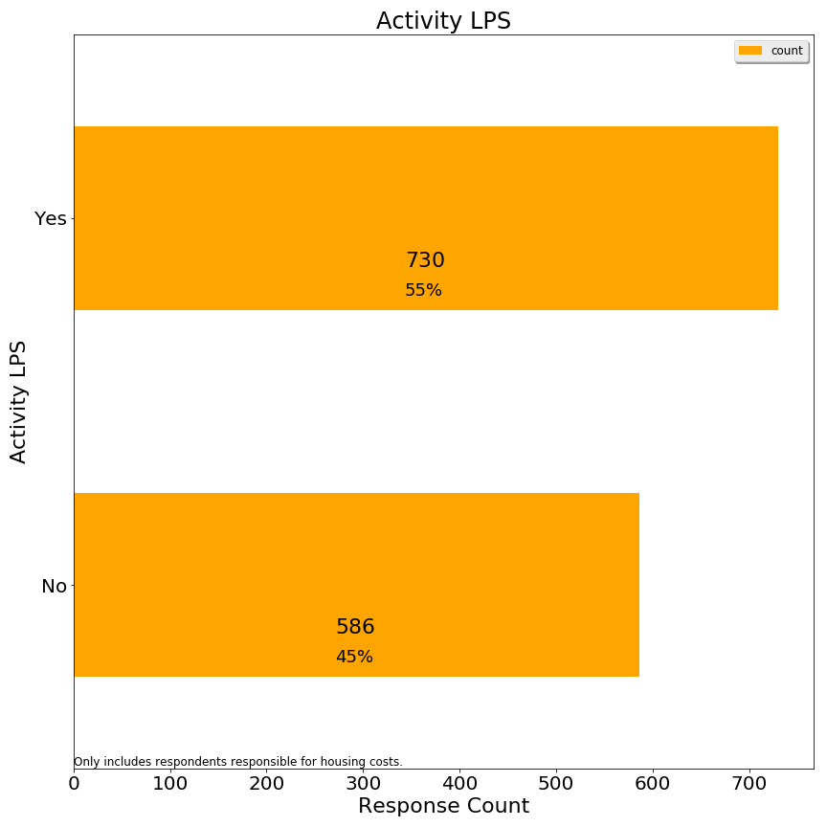

Q11. Participated in any town provided program or service for seniors

Lexington offers a variety of programs and transportation services for seniors.

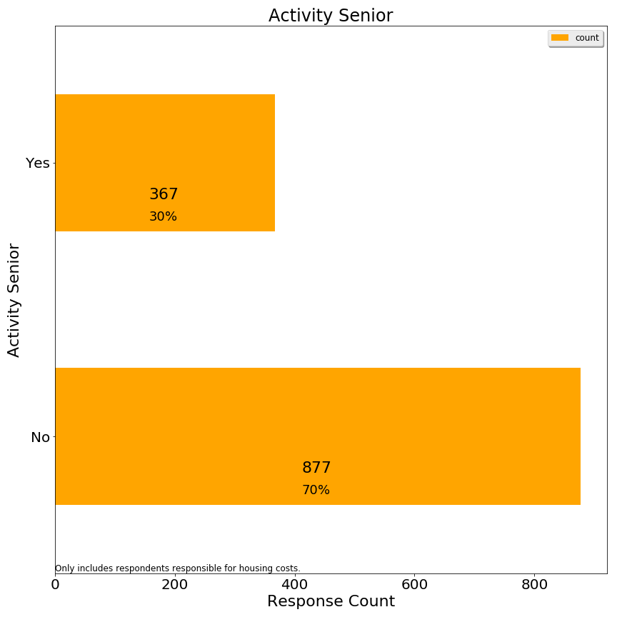

Q12.Used Cary library or attended a library event

Cary Memorial library hosts events and is Lexington’s only library at present.

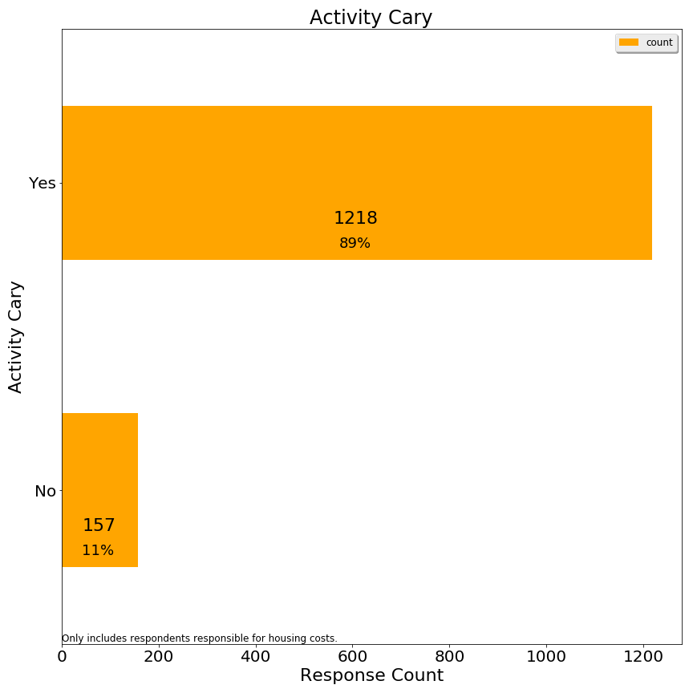

Q13.Served town government in any capacity (employee, committee member, town meeting member, elected representative)

Lexington is governed by representative town meeting and has 21 citizens from each of 9 precincts, along with various town committees which include citizens not in town meeting.

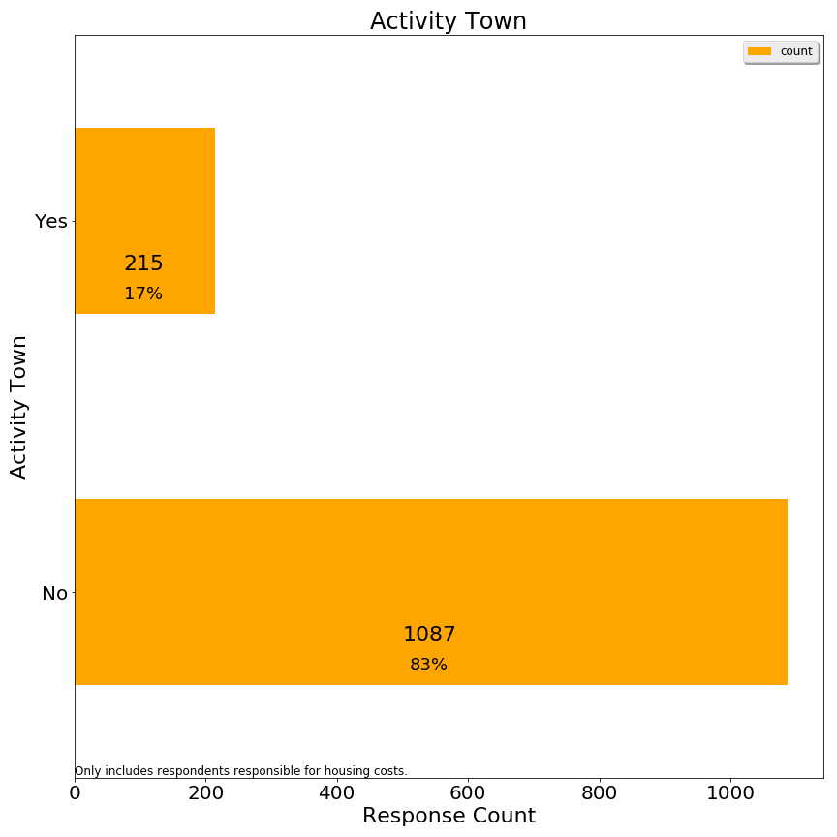

**Section 2: Affordability**

Q1. Are you aware that the Recreation & Community Programs Department offers financial aid for programs and services?

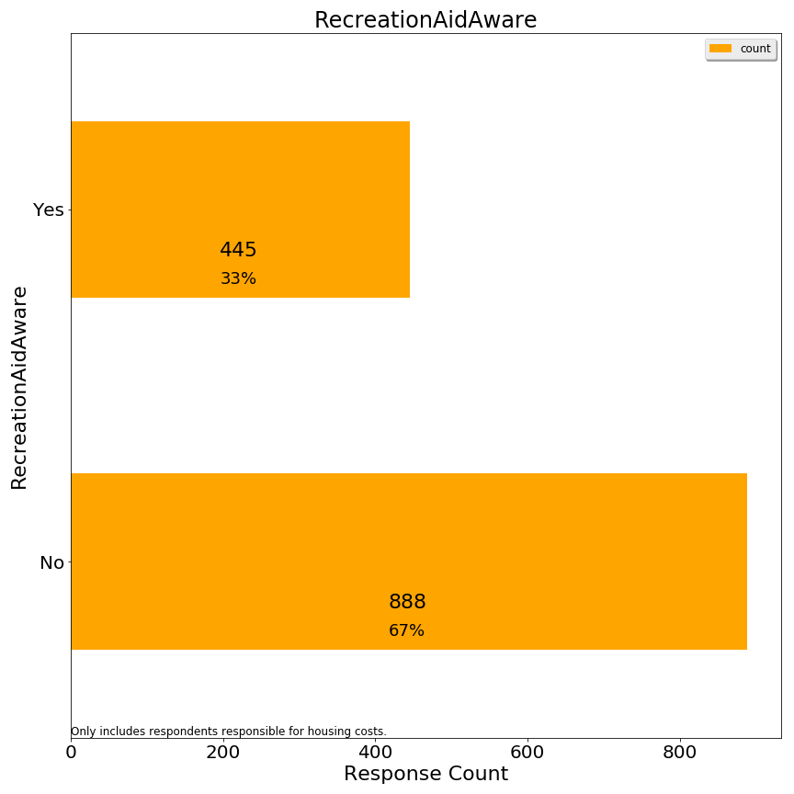

Q2. Has a household member received this type of financial assistance to participate in a program or service?

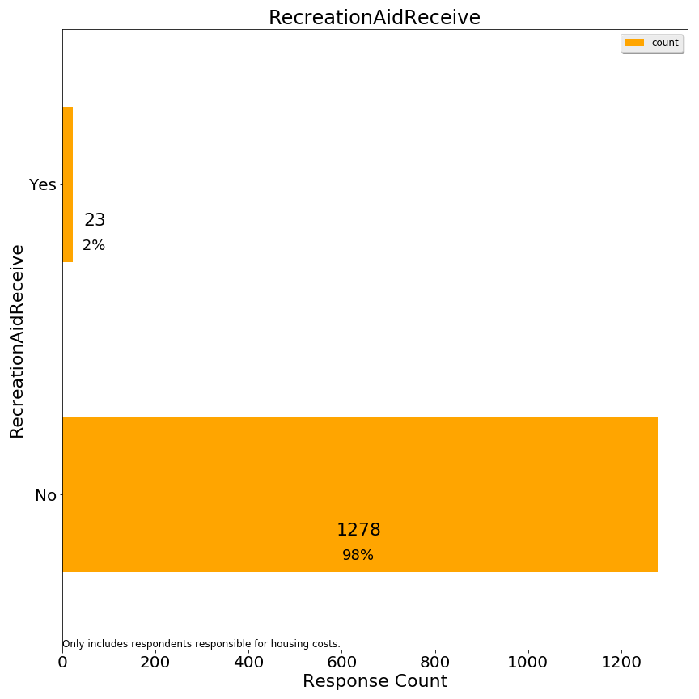

Q3. If your primary residence is rental, please indicate your monthly rental cost:

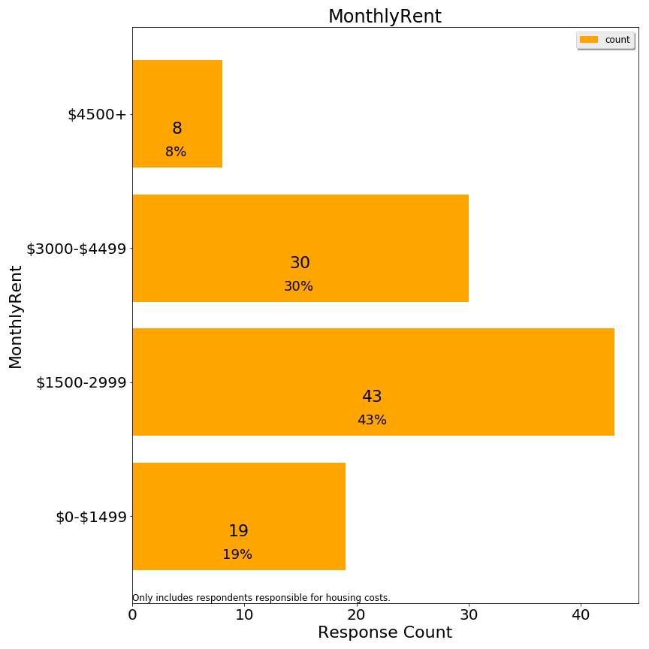

Q4. If you own your primary residence, please indicate your total monthly housing payment (mortgage, insurance, property taxes):

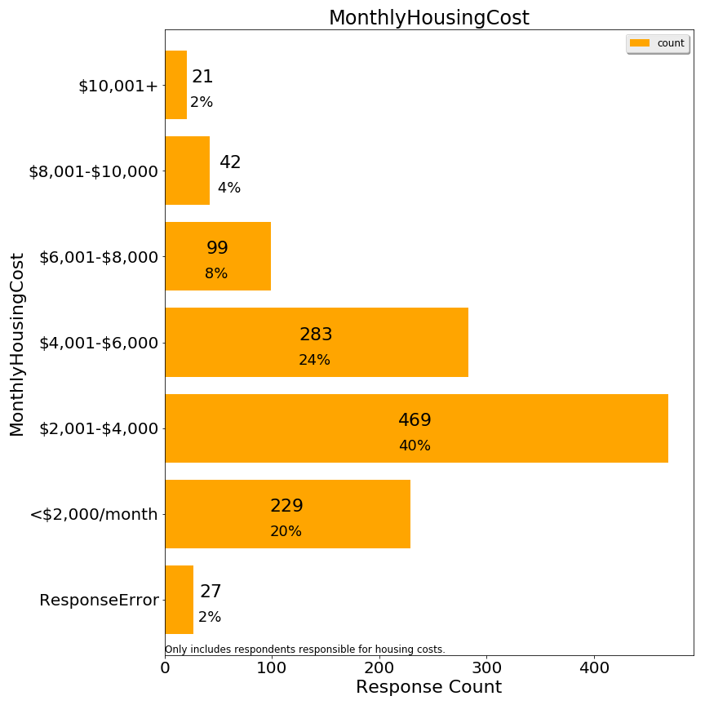

As indicated, some $10,001+ responses were re-coded as ResponseError because it was not conceivable to the committee how it corresponded to a lower home value. We presume the respondents interpreted the figure as an annual cost when they saw a figure such as $10,001+.

Q5. Do you receive a property tax deferral or property tax credit due to limited income?

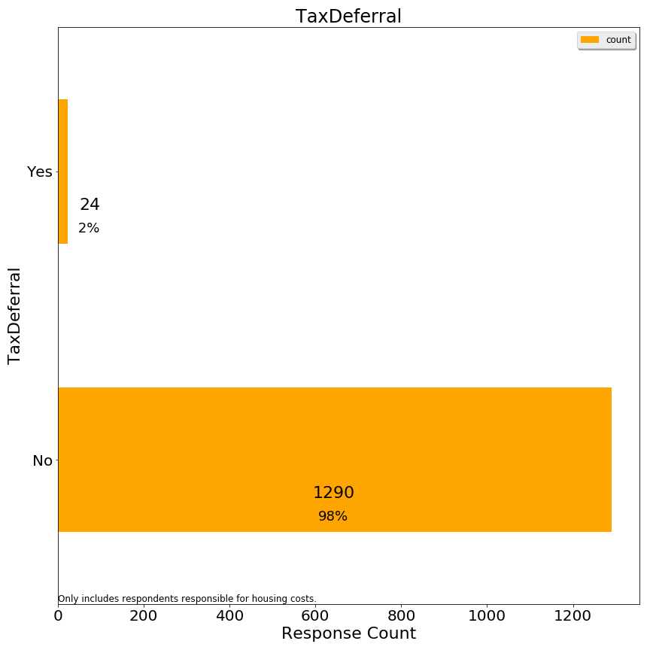

Q6. What level of stress does your household experience with payment of monthly housing costs?

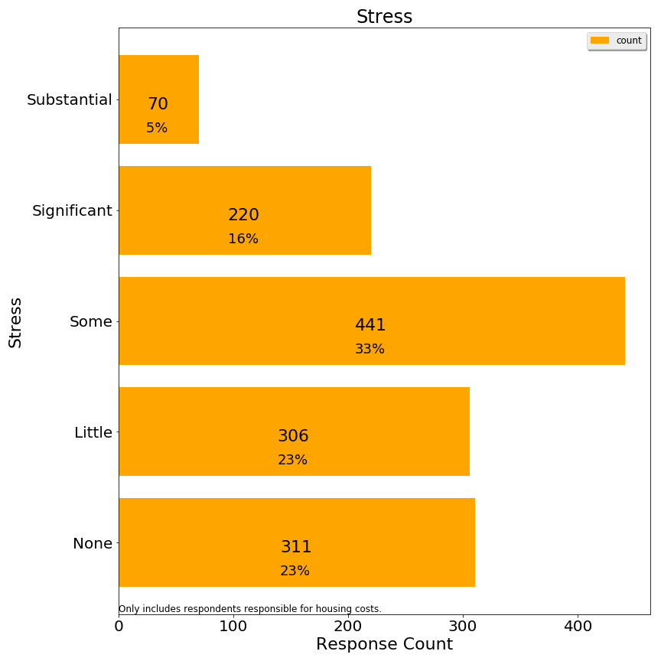

These stress codes were then grouped into high, medium and low for analysis purposes.

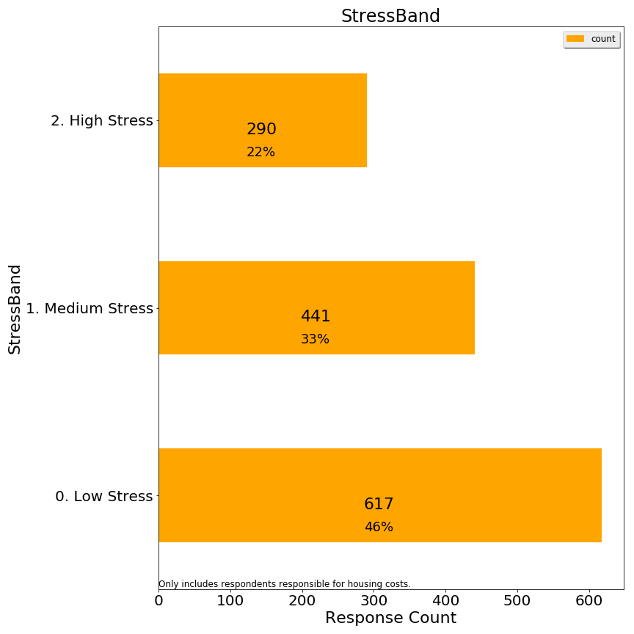

Q8. Thinking about all the costs of living in your owned property or rental (rent/mortgage, home maintenance, condo fees, property taxes, insurance, utilities), what portion of these costs do you estimate is related to property taxes?

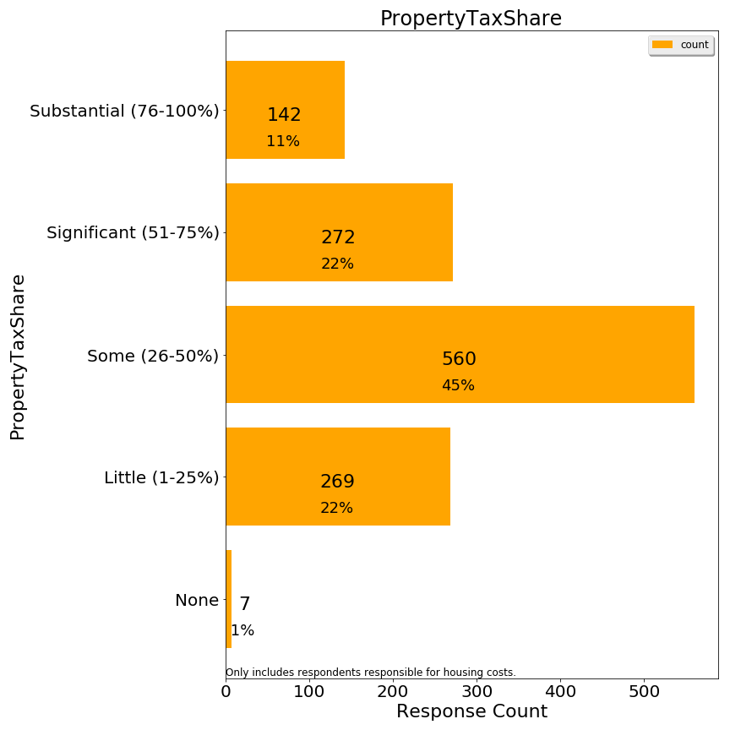

Some respondents criticized the labels which were attached to the %s, even suggesting that these labels implied taxes should be high. In hindsight, labels should not have been attached to the percentages.

Q9. Are you responsible for the housing costs at your residence (i.e. owner or lessee)?

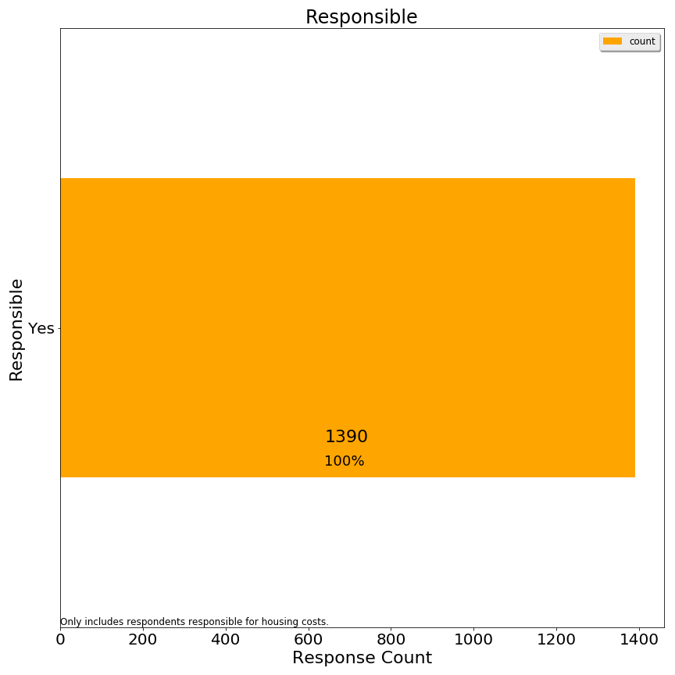

Q10. Are you considering relocating away from Lexington in the next 10 years?

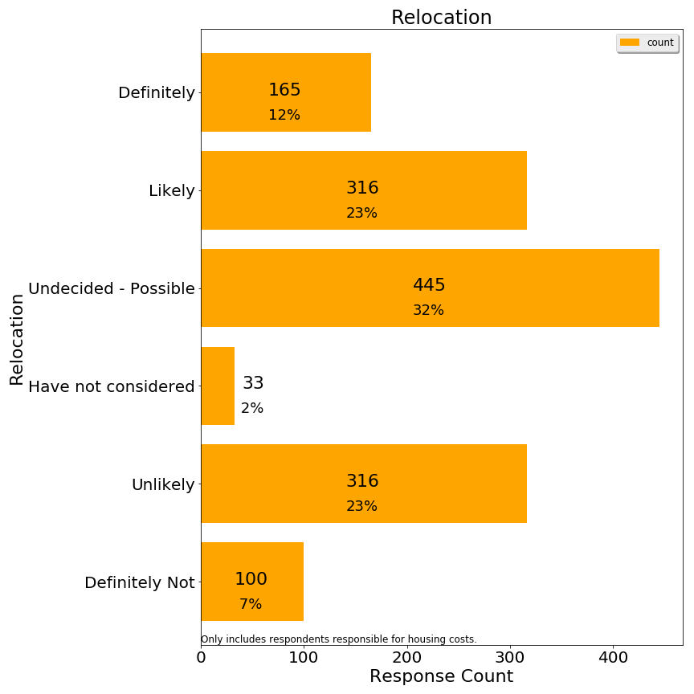

We regrouped responses for correlation analysis using a simpler relocation band variable:

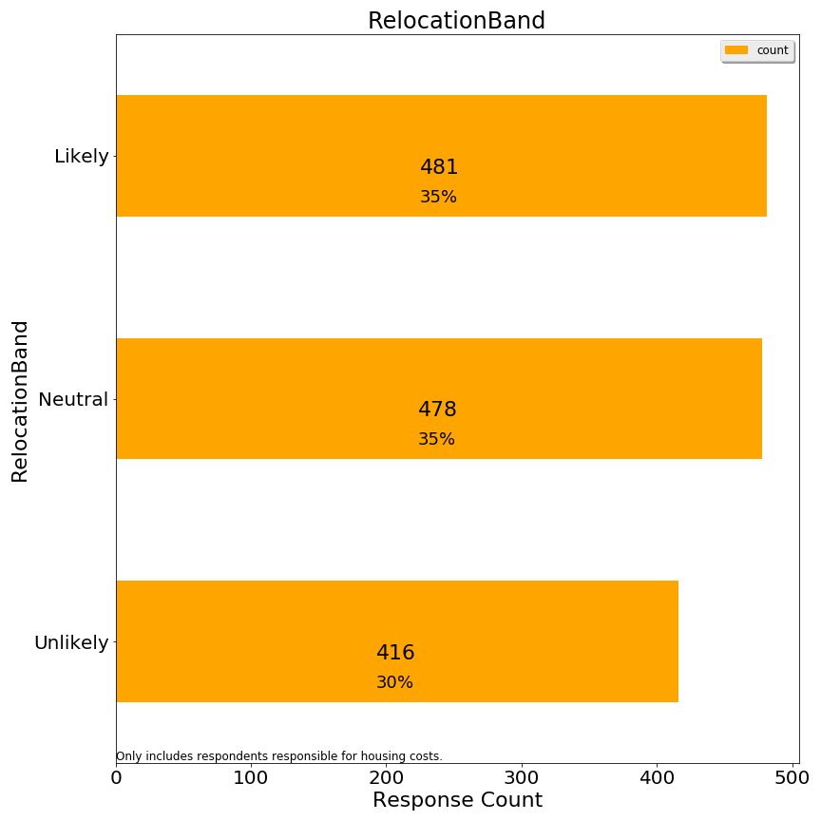

**Second 3: Demographics**

Q1. Age (respondent)

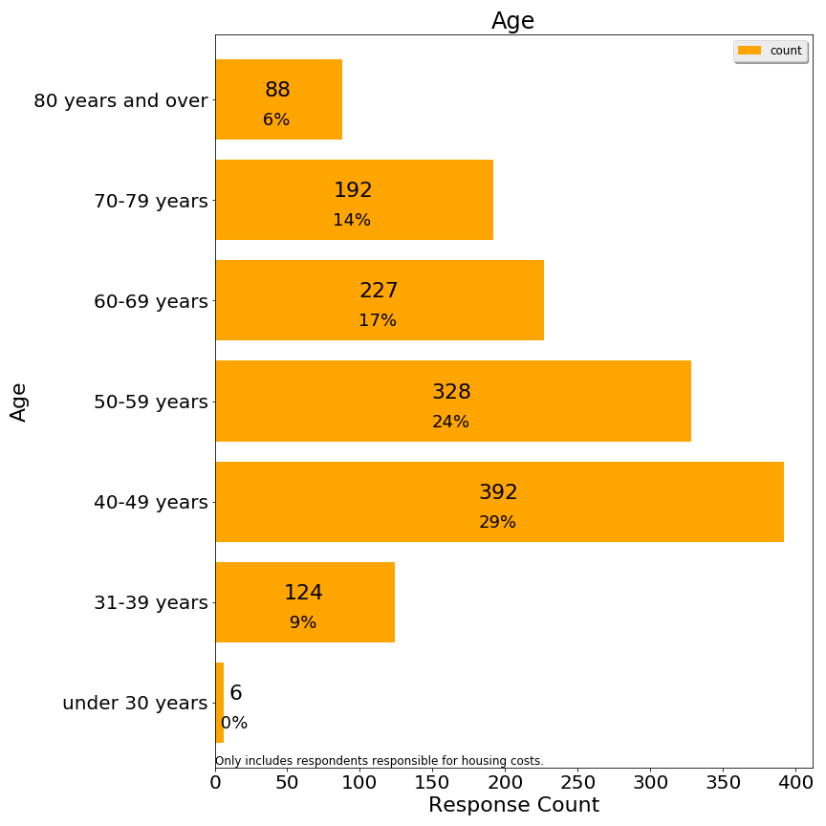

Q2. Size of household (number of people)

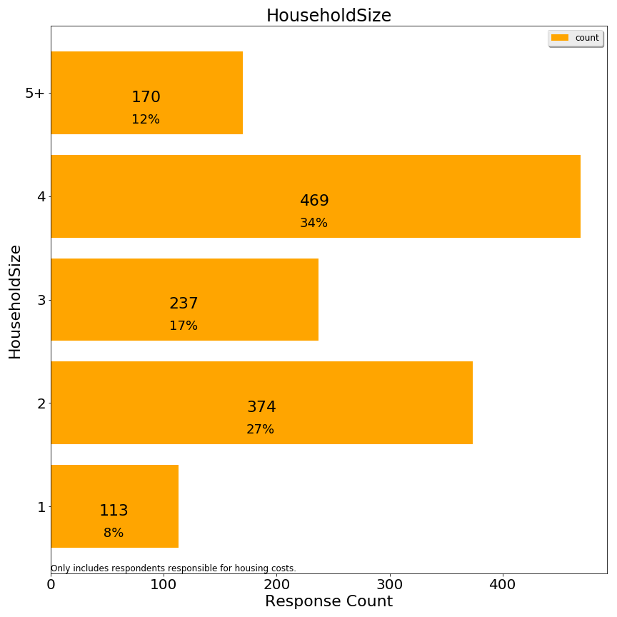

Q3. Disabilities within household (check all that apply)

[TBD: fill in chart; this was a complex question to summarize]

Q4. Length of time living in town (respondent)

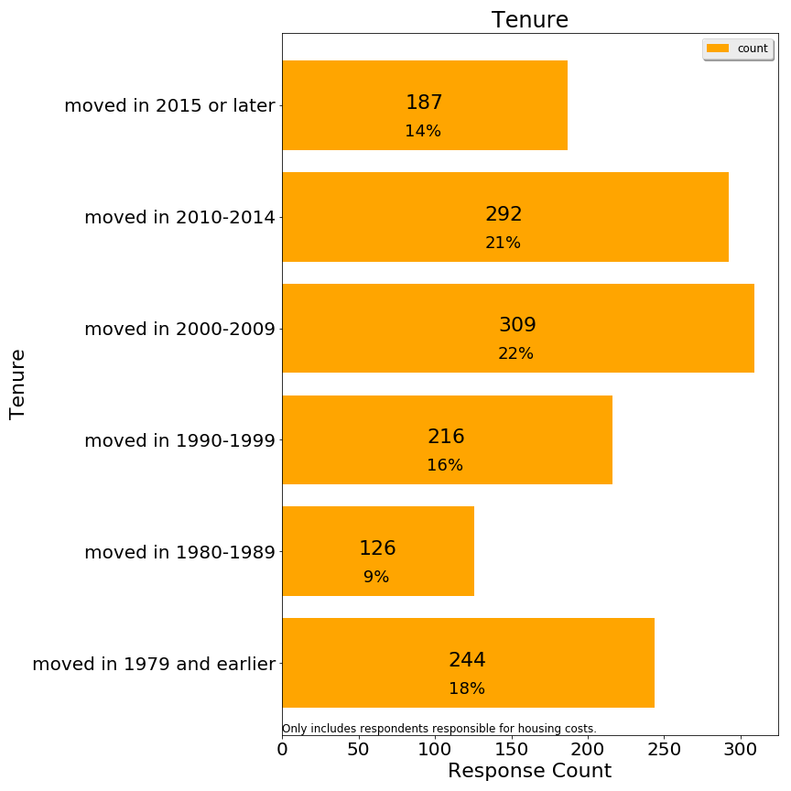

This question was ambiguous for respondents who moved in and out of Lexington multiple times.

Q5. What type of property is your residence?

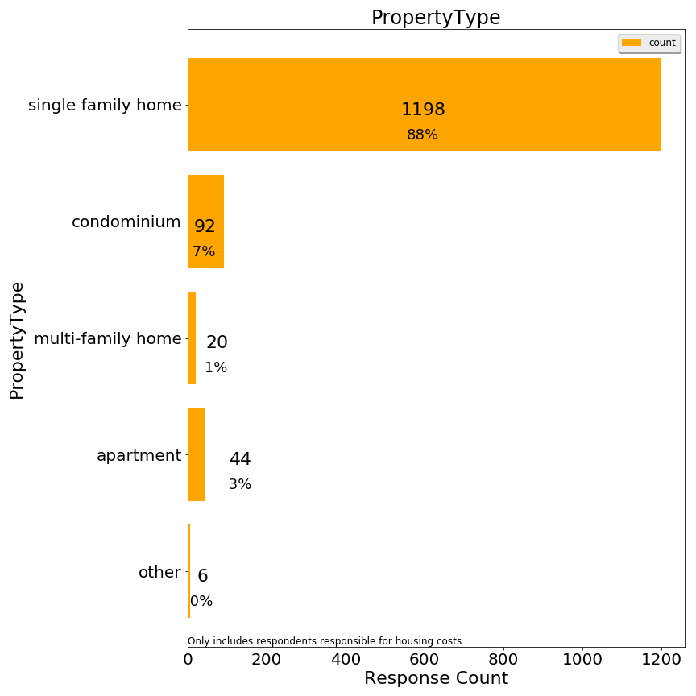

Q6. Approximate market property value of your Lexington residence (if owned):

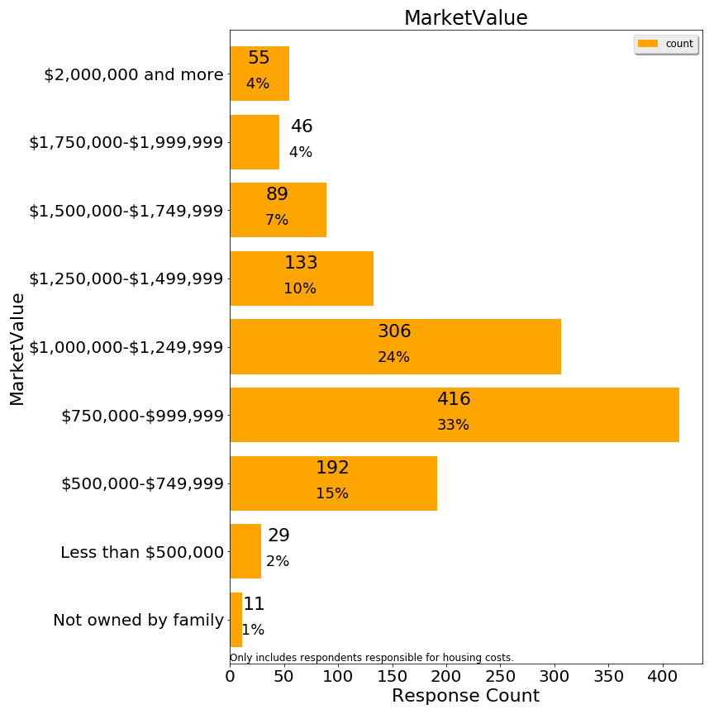

Q7. Please indicate your approximate household income in the past 12 months

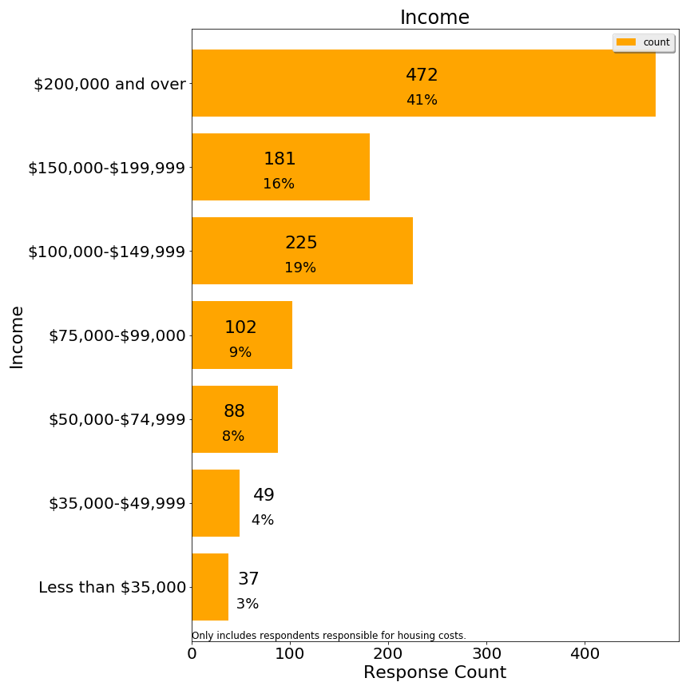

Additional charts on frequency distribution of derived variables are significant:

Number of Activities Reported

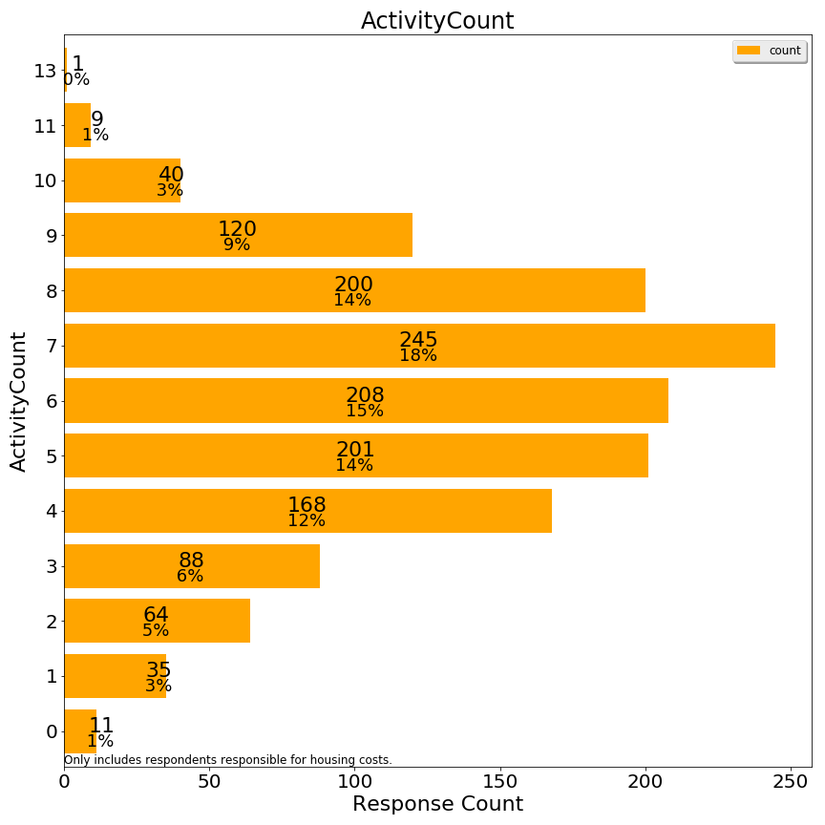

Whether respondent owns or rents



Number approximately qualified for a means-tested exemption (without asset test)

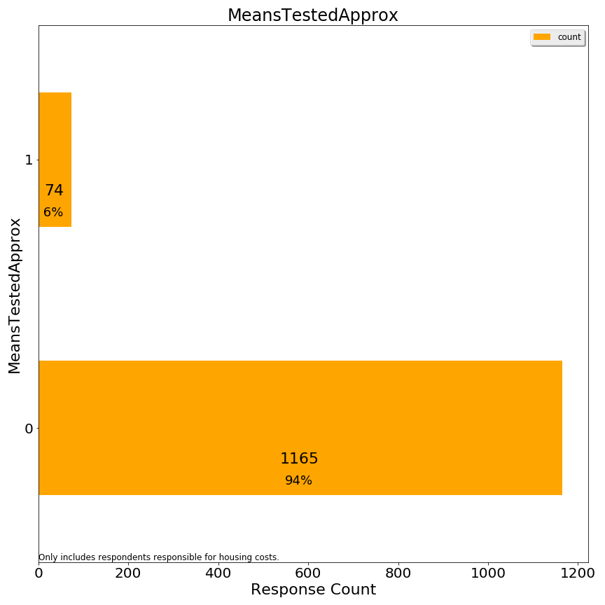

1. https://en.wikipedia.org/wiki/Precision_and_recall
2. <https://www.census.gov/acs/www/data/data-tables-and-tools/>
3. Imputation of income could add about 100 respondents, but we have not elected to do any imputation.